Windchill Customization Basics

Customization Overview

Configuration Options

Properties

- Properties are created in text files in the Windchill codebase and control overall system configuration.

- Properties are stored in files with the .properties extension. Changing most properties requires a restart of the Windchill method server.

- A complete set of properties and descriptions for the wt.properties, tools.properties, and db.properties files can be found in the properties.html file in the Windchill codebase directory.

Preferences

- Preferences are set through the Windchill user interface and do not require a server restart.

- Preferences can be configured to control the whole Windchill installation, or can be used more narrowly to control an organization’s or an application container’s (e.g. Product, Library), or a specific user’s setup.

Object Initialization Rules

- A business analyst can set up rules that tell the system how to initialize newly created objects.

- For example, the business analyst can set the system up to number parts according to the company’s part numbering policies (e.g. auto-number). The business analyst may also set the system up to require the user to enter a manual number, or alternatively, set the system up so that if the user does not enter a number, the system will assign one.

- As another example, the business analyst can set the system up to automatically assign objects of certain types to certain workflows; or, alternatively, the business analyst can configure the system with appropriate workflows by object types and it will be up to the end user to select the appropriate workflow to use. For more sophisticated needs, the business analyst can set the system up to route an object appropriately based on the values of meta-data attributes provided by the end user.

- Object initialization rules provide significant flexibility in adapting a Windchill system to a specific customer’s environment and business process needs.

Workflow Templates

- Windchill provides a very powerful workflow configuration and execution engine. The workflow engine of Windchill can model virtually any business process which can be modeled via an easy-to-use drag-and-drop tool.

Soft Typing

- Soft Typing is the name of the set of Windchill capabilities that allows a customer to, at runtime, add additional types and attributes to the out-of-the-box Windchill Schema.

- This is done without having adding additional tables to the database, without restarting the database, and without restarting the system.

- No user interface modifications are necessary as the Windchill user interfaces automatically accommodate (e.g. adapt to) these additional Types and Attributes.
- The general guideline to be followed is this: If a need can be satisfied by soft typing, then it should. That is, do not customize (i.e. create modeled extensions) to the out-of-the-box schema. The reason for this rule is to minimize the total cost of ownership of Windchill and minimize upgrade costs and burdens. This, in no way, is a limitation on the customizability of Windchill; but, rather, the intent of the rule is to reduce the cost of ownership.

Organization and Container Templates

- Creating an organization or an application container (e.g. Product/Library/Project/Program) requires that you provide a template to initialize the container with.

- A template allows you to configure the business rules of the created container. For example, you can specify what approval processes are to be followed, who has access to create and/or view information, what roles are required and who the role players are, what numbering and versioning rules should be followed, etc.

Customizations

- Windchill is an open system that is fully supports customizations at the schema, server, and UI levels.

- An extensive set of APIs are published, documented, and supported to enable these customizations.

- In order to reduce the cost of ownership, if changing other mechanisms such as properties or preferences satisfy the business need, then customizations should not be used.

Data Model Customizations

- Windchill Information Modeler is one of the Windchill development components that can be used to customize your Windchill environment.
- Information Modeler contains the Windchill modeling files and source code that you will use to develop your customizations.

- Custom Java Annotations are used to model business objects.

- Information Modeler provides the most powerful capabilities for creating custom business objects and relationships in Windchill systems, but requires greater development skills and is less flexible than using subtypes.

- For example, subtypes can be added and changed by an administrator while the system is running, but model changes must be made by a skilled Java developer during strictly managed checkpoints.

- On the other hand, modeled objects can be created by assembling specific collections of Windchill plug-and-play interfaces to create unique server behavior but subtypes can only be created as super types of existing modeled classes with additional attributes.

Service Customizations

- Windchill supported server-side customizations to enable certain business processes or enforce business constrained.
- Any kind of customization can be performed.
- The most common types of customizations falls into one of the following categories:

  - Process form data submitted through the user interface
  - Validate data - (e.g. Do not allow the user to enter a Need Date for a Change Request that is more than 30 days into the future)
  - Implement service listeners - (e.g. Create a listener that waits for any data to be checked in and populate an MRP – Material Requirements Planning system with appropriate data)
  - Get/Put data in an external systems - (e.g. when the user navigates to a part’s details, get the cost of the part from the ERP system and display it in the same UI)

User Interface Customizations

- The Windchill Client Architecture is a Windchill-aware JSP framework. It provides very high-level building blocks known as common components which make Windchill UI development a very efficient process done with ease.

Info*Engine

- Info*Engine provides data access and integration capabilities to access Windchill data, remote Windchill systems and non-Windchill data and services (through adapters).

- Info*Engine components can be used in many different software and hardware configurations to meet your business requirements for accessing, managing, and presenting data from many different information systems.

- All basicInfo*Engine solutions take advantage of five fundamental concepts: JSP pages, tasks, webjects, groups, and the virtual database.

- Both JSP pages and tasks are text-based documents that define howInfo*Engine either displays or retrieves information.

- Webjects are the means by whichInfo*Engine JSP pages and tasks gather, manipulate and display data.

- Groups are the chunks of information generated and manipulated by JSP pages and tasks.

- The virtual database (VDB) is the special holding area where groups are stored until they are manipulated or passed along by JSP pages and tasks.

Custom Reports

- Custom reports can be created using Windchill Query Builder or the Windchill-integrated third-party report authoring tool, Cognos.

- Use Windchill Query Builder if you would like to create very simple tabular reports and your site is not configured for third-party reporting tool, Windchill Business Reporting.

- To create tabular reports, visual and graphical reports, dashboard reports, and drill-down reports, use the optional third-party reporting authoring tool.

- This optional authoring tool also allows you to modify out-of-the-box reports.

- Using the authoring tool you can create new reports that include charts and graphs (Crosstabs, bar/3D bar, pie, gauge, funnel, scatter and more).

- The report data sources that are required for creating custom reports in report author tool can be created using Info*Engine report tasks and Query Builder templates.

Windchill Customization Points

- To determine if a class, or one of its methods, is part of the Supported API, consult the Javadoc for that class.

- For each class, the Javadoc contains a Supported flag, and an Extendable flag.

- Individual methods within a Supported class may also be flagged as Supported.

- Windchill Java Doc comes by default with Windchill Installation.

  - Location: <WT_HOME>/codebase/wt/clients/library/api/index.html

  - Accessible from:

- UI:
  - Set preference Client Customization to Yes
  - Browse to Customization > Documentation > Javadoc
- URL: hostname/wt/clients/library/api/index.html

- If a class (or method) is flagged as Supported: true, it indicates that the class or method may be referenced by customized code.

- If a class is flagged as Extendable: true, it indicates that the class may be extended.

- If a class is not part of the Supported API, then neither are any of its methods.

- If a class is part of the Supported API, that does not indicate that its methods are, too.

- For a method to be part of the Supported API, its Javadoc must also state “Supported API: true”.

The Windchill Development Environment

Windchill Folder Directory Structure

The image below shows the Windchill directory structure after you install all available components.

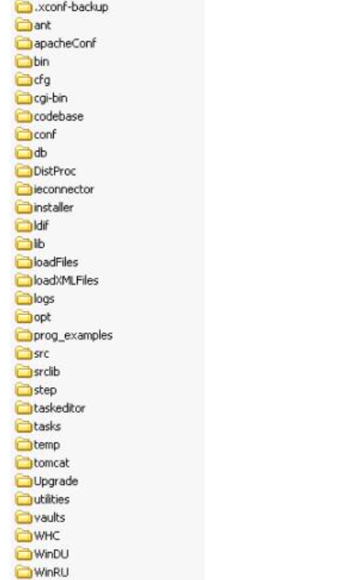
ant
Installation of supported version of Ant.
apacheConf
Contains configuration files forPTC HTTP Server (powered by Apache) and Windchill
bin
Contains various batch scripts, such as ToolsSetup.bat.
buildlogs
Default location for logs created by running Windchill Ant scripts.
cgi-bin
Contains the Windchill common gateway interface wrappers.
codebase
Contains the runtime environment files.
conf
Configuration files for PTC HTTP Server, Info*Engine and other applications.
db
Contains the database properties file and SQL scripts.
ieconnector
Contains the Info*Engine JCA (Java Connector Architecture) which is used for J2EE integrations (EJB or App Server connectivity). It is also used by Info*Engine JCA enabled standalone java SOAP clents.
installer
Contains files used by, or created by, the installation process, including installation logs.
ldif
Files related to PTC's InterComm Viewer.
lib
Contains the wtbeans.jar file, which holds the Java bean components that have been developed for use with Windchill clients.
loadFiles
Contains files used to load initial data.
loadXMLFiles
Contains new style xml files used to load initial data.
logs
Default location for trace logs when logging is turned on.
Module
Contains Windchill modules' model files, which are used for customization development.
opt
Install folder for some optionally installed functionality.
prog_examples
Contains Info*Engine program examples
src
Contains files for customizations, and rbInfo files for text.
srclib
Contains module jar files.
step
Contains STEP application related files.
taskeditor
Contains the Info*Engine task editor startup scripts, help files reside and is the runtime directory for the task editor.
tasks
Contains Info*Engine tasks.
tomcat
Embedded Servlet Engine (based on Tomcat) installation.
temp
Temporary files used by Windchill.
Upgrade
Contains files to facilitate the upgrade process.
utilities
Contains various Windchill utilities.
vaults
Default file vault location.
WHC
Contains the Windchill Help Center which consists of the online help.
WinDU
Directory of xml files that declare the existence of tasks that are executable by the Windchill Diagnostic Utility.

The codebase Directory

- The codebase directory contains executable class files, property files, and other files that contain information needed by the runtime environment for Java and Web processing.

The src Directory

- The src directory contains the source files needed for application development.
- In the wt directory and its package subdirectories, you will see the following kinds of files:
  - Localizable ResourceBundles (.rbInfo and .java) files, which contain customizable display text for EnumeratedTypes and business elements and UI strings.

Property Files

wt.properties file

service.properties file

- The service.properties file contains properties used by the Windchill service delegate mechanism.
- This mechanism is a general facility for adding delegate classes to an existing service to implement new, customized behavior.
- In this context, service can mean any sort of Java mechanism that provides functionality to other classes.

tools.properties file

- wt.generation.sql.dir, which specifies where SQL scripts will be generated.
- wt.generation.sql.xxxTablesSize, which sets default sizes for tables.

- Because tools.properties is contained within the SystemGeneration.jar, user overrides to these properties are placed in codebase\user.properties.

user.properties file

- The user.properties file contains user overrides that are used by the System Generation tools.

- Configuration overrides for System Generation should be configured in user.properties using the xconfmanager utility.

db.properties file

- The db.properties file contains properties that are used by the Windchill persistence layer to access the database.
- They can be set in the wt.properties file but are usually kept in a separate file identified by the wt.pom.properties entry.
- You should maintain it in a secure location as there is password in this file.
- The values in the separate file override the values in the wt.properties file.

Properties and Property Files

- codebase/service.properties – properties specifying the TemplateProcessor, ActionDelegate, URLActionDelegate, and FormTaskDelegate to use for a given action/object type.

- codebase/htmltemplate.properties – properties specifying the HTML template to use for a given action/object type.

- codebase/htmlcomponent.properties – properties specifying the HTMLComponent to be used for a given element.

- codebase/wt.properties – miscellaneous template processing properties such as colors of various page components (wt.html.color.*), the text encoding used for various locales (wt.template.encoding.*), and the default parameters used for various page tags (wt.templateutil.component.*).

- The first three of these files contain properties for what are typically known as “application context services.” These require special loading at runtime and are described in more detail in the following section.

- The properties in wt.properties are simple name/value pairs that are loaded into a Java Properties class instance at runtime.

Application Context Service/Resource Properties

- These are properties, generally used by a factory class, for locating a delegate, service, or resource. They have one of the following formats:
- wt.services/svc/default/<Service Type>/< Selector >|null/<Requestor>/<Service
Priority Number>=<Service Class Name>/<duplicate or singleton>
or
wt.services/rsc/default/<Resource Type>/<Selector>|null/<Requestor>/<Service
Priority Number>=<Resource Name>
- The first format is used to locate a Java service or delegate class to perform a function or provide a service.
- The second format is used to locate a resource file --- for example, a HTML template file or an icon image file.
Definitions
- Service Type = the type of service or delegate referenced by this property
- Resource Type = the type of resource referenced by this property
- Selector = an identifier used to specify the context in which this service or resource is to be used (for example, an action name).
- Requestor = the object class for which the service, delegate, or resource is to be used
- Service Priority Number = a priority rating used to choose between valid delegates
- Service Class Name = name of delegate or service class for the given Service Type, Selector, and Requestor
- Resource Name = name or resource for given Resource Type, Selector, and Requestor
- Duplicate or singleton = a flag to indicate whether the server should instantiate a shared instance of a delegate class or create a new one for each use. If neither is specified, duplicate will be used.
- This is an example property for a template processor:

wt.services/svc/default/wt.enterprise.TemplateProcessor/AddAlternates/
wt.part.WTPartMaster/0=wt.part.AlternatesLocalSearchProcessor/duplicate
where
Service Type = "wt.enterprise.TemplateProcessor"
Selector = the action name "AddAlternates"
Requestor = "wt.part.WTPartMaste

- Any service class that incorporates an HTTPState object should be made duplicate. This would include instances of BasicTemplateProcessor, and FormTaskDelegate, NavBarActionDelegate.
- To be loaded correctly at runtime, files containing application context service properties must be listed for one of the following properties in wt.properties:
wt.services.applicationcontext.WTServiceProviderFromProperties.defaultPropertyFiles
wt.services.applicationcontext.WTServiceProviderFromProperties.customPropertyFiles

- Property files will be loaded in the order listed, and files listed for defaultPropertyFiles will be loaded before those for customPropertyFiles.
- If the same property is found in more than one file, the value for the one loaded last will be used.
- Any custom properties should be placed in the latter list.
- The grouping of properties into various properties files is unimportant to the system and based primarily on ease of maintenance. If a TemplateProcessor property is put in the htmltemplate.properties file instead of service.properties the system will still find it.

Application Context Service Properties for Subtypes

- Properties for client features that allow you to specify different services or resources for different subtypes must be put in a property file listed for one of the following properties in <Windchill>/codebase/wt.properties:

wt.services.applicationcontext.TypeBasedServiceProviderFromProperties.defaultPropertyFiles

wt.services.applicationtext.TypeBasedServiceProviderFromProperties.CustomPropertyFiles

- To add typed service property entries for your custom HTML clients, we recommend you put them in a new properties file or files used only for your customizations. This file should be added to the list of files for TypeBasedServiceProviderFromProperties.CustomPropertyFiles

Getting Started With Windchill Customization

Example Overview

The customization will introduce a new class, Pet. Pet will represent an animal (a pet) and will define the following properties:
• name the name of the pet
• kind an enumeration consisting of dog, cat, gerbil, etc.
• dateOfBirth a date represeting the pet’s birthday
• fixed a boolean indicating whether the pet has been spayed or neutered.

Additionally, the Pet will incorporate the following:
• ContentHolder (a domain interface) to store pictures of the pet
• Ownable (a domain interface) to support assigning the pet to an owner
• WTObject (a base class) to provide basic functionailty.

Pets can be stored in the Windchill database and support basic “CRUD” operations (Create, Read (query), Update, Delete).

Creating the Class

1. Create the Pet class.
a. Navigate to File > New > Class.
b. Set Package to com.acme
c. Set Name to Pet
d. Click Finish.
The result will be an empty class.

2. Make the Pet persistent.

- Annotate the class declaration with @GenAsPersistable by typing “@GAP” followed by Control + Space;
- Save Pet (Control-s). Pet will immediately show two compile errors, as follows:
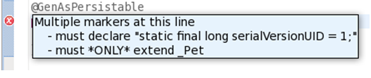

This is expected.

- Resolve them by:

  - Adding the required declaration to Pet’s body
  - Making Pet extend _Pet

- Save Pet again. Pet now extends _Pet, which implements wt.fc.Persistable, resulting in two new errors.

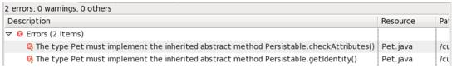

Rather than implement these directly, make WTObject the super class of _Pet by adding superClass=WTObject.class to the annotation above (both superClass and WTObject will complete, and Eclipse will automatically import WTObject as part of the completion).

- Save Pet again. The result, which will compile cleanly, is as follows:
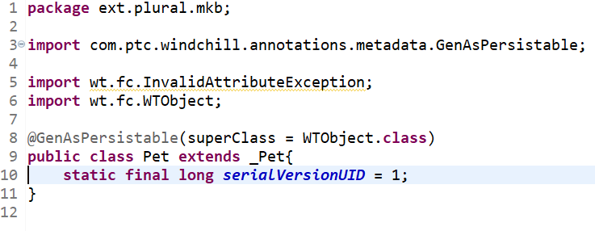

- Create the no-argument factory method for Pet, which consists of the following:
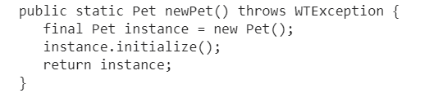

Windchill persisted objects require the use of factory methods similar to the “newPet()” factory method over constructors. They are paired with initialize methods accepting the same arguments so child classes can inherit logic present in the parent class’s methods. In this case, an explicit initialize method is unnecessary as Pet does not contribute functionality; here, the implementation inherited from WTObject is sufficient.

3. Add ContentHolder and Ownable to Pet. Windchill utilizes Java interfaces to provide domain functionality to persistent business classes. ContentHolder gives the ability to store files (content) and Ownable the ability to take ownership of a business object.

a. Add “, interfaces={ContentHolder.class, Ownable.class}” after the superClass annotation member. Make sure to use Eclipse “Control + Space” completion auto-import the interfaces.

b. Save Pet.
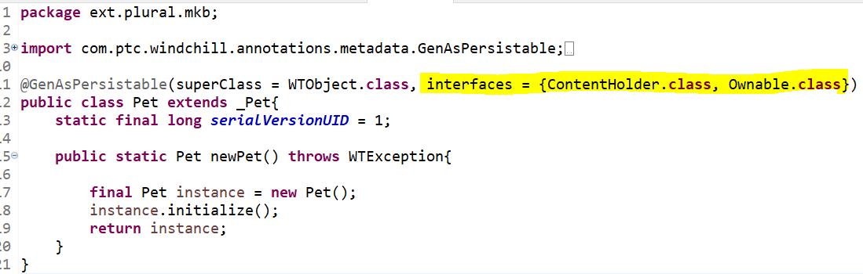

4. Add name, dateOfBirth, and fixed as properties to Pet.

a. Declare the properties annotation member by adding a comma after the closing “}” of interfaces, then adding a newline, and then inserting the following

b. All properties will be included between the “{}”s for properties, each on their own line. First, add name as follows:

@GeneratedProperty(name="name", type=String.class,
columnProperties=@ColumnProperties(index=true),
constraints=@PropertyConstraints(required=true, upperLimit=60))

This property declares name, of type String. The name is required, must be 60 characters or less in length, and will be indexed in the database.

c. Next, add dateOfBirth immediately following name. It will be necessary to add a comma to the previous line to separate the two declarations:
@GeneratedProperty(name="dateOfBirth", type=Timestamp.class)

d. Finally, add fixed (a boolean): @GeneratedProperty(name="fixed", type=boolean.class

5. Create PetKind, an enumerated type consisting of common pet kinds.
a. Navigate to File > New > Class.
b. Set Name to PetKind
c. Click Finish.
Add the GenAsEnumeratedType annotation to the class declaration and make the class extend _PetKind (ignore the warning). The result will look as follows:
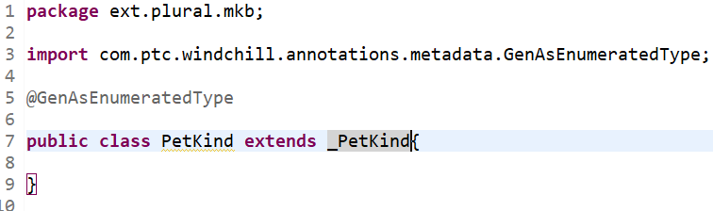

6. Create PetKindRB.rbInfo, a resource bundle storing kinds of pets.
a. Select PetKind.java and Type Control-N.
b. Select General > File and click Next.
c. Give PetKindRB.rbInfo as the File name.
d. Click Finish.
e. Make the contents of PetKindRB.rbInfo as follows (and save it):
ResourceInfo.class=wt.tools.resource.EnumResourceInfo
dog.value=Dog
dog.order=10
cat.value=Cat
cat.order=20
gerbil.value=Gerbil
gerbil.order=30

7. Add kind to Pet.

a. Place kind between name and dateOfBirth: @GeneratedProperty(name="kind", type=PetKind.class, constraints=@PropertyConstraints(upperLimit=40))

The stored value of an enumerated type is the key value (dog, cat, gerbil) as opposed to the display value (Dog, Cat, Gerbil). An upper limit of 40 was specified as it’s a more than sufficient value to store the keys.

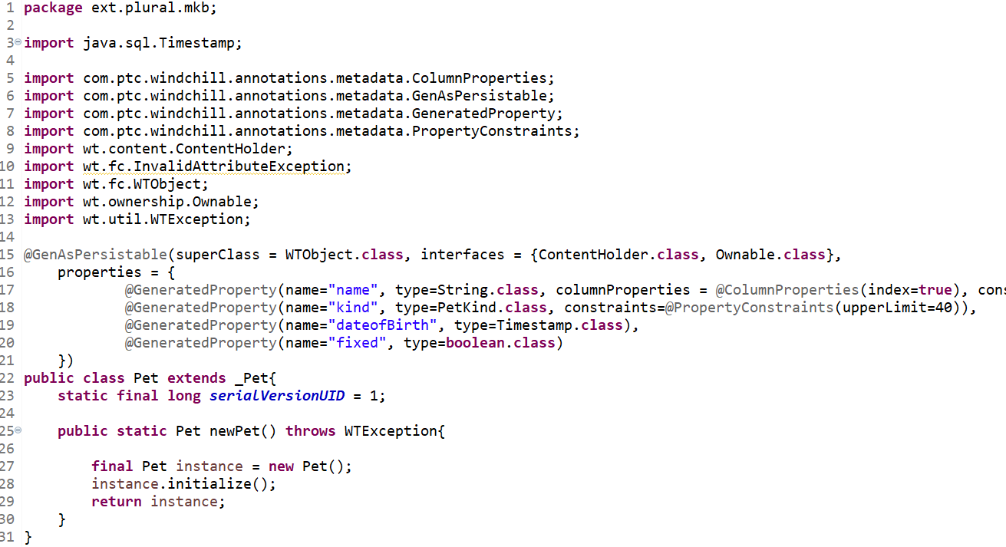

8. Compile PetKindRB.rbInfo.

a. Find or start a Windchill shell.
b. Run the following command: ant -f bin/tools.xml bundle -Dbundle.input=ext.plural.mkb.PetKindRB
- When above command does not build the desired files, use ResourceBuild command to update the specific file.

9. Ensure Pet, PetKind compile with Ant.
a. Reuse Windchill shell from previous command
b. ant -f bin/tools.xml class -Dclass.includes=ext/plural/mkb/Pet.java
c. ant -f bin/tools.xml class -Dclass.includes=ext/plural/mkb/PetKind.java

10. Generate SQL scripts.
a. Reuse, again, Windchill shell
b. ant -f bin/tools.xml sql_script -Dgen.input=ext.plural.mkb.*

11. Generated SQL files will be located under db/sql as shown below.
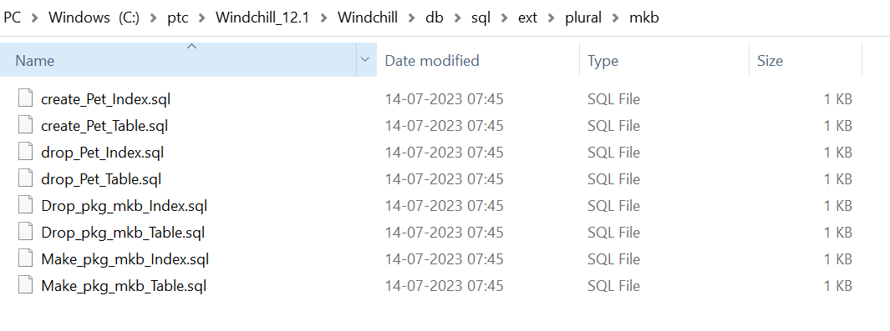
12. Load schema for Pet.
a. cd to the db/<xxx> directory from Windchill Shell.
b. Run the script as shown below.

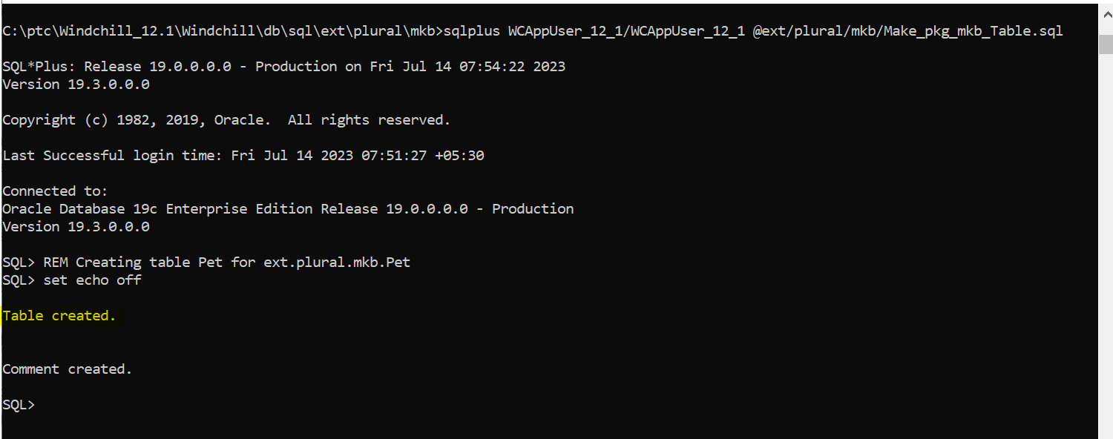

c. Repeat for @ ext/plural/mkb/ Make_pkg_mkb_Index.sql
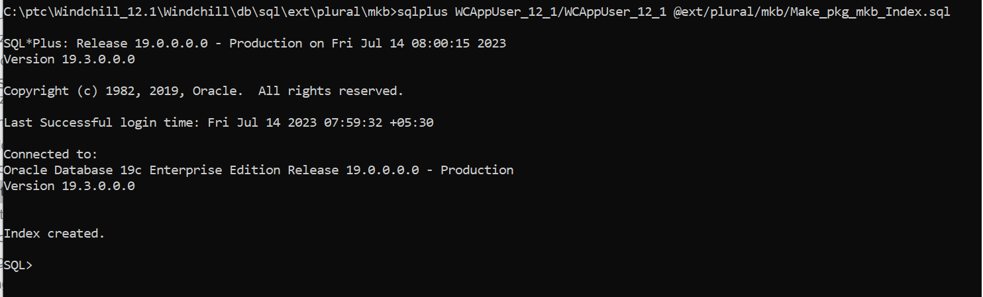

Verifying the customization

The customization is incomplete: no user interface (UI) exists to manage Pet objects.

Errors: If the method server fails to start with the error “Infor resource not found” then follow the below article.
Article - CS129745 - Method Server fails to start with error wt.introspection.InfoNotFoundException: Info resource not found for &lt;classname&gt; in Windchill PDMLink (ptc.com)
Then again compile all the java classes, clean cache and restart Windchill.

Pet customization notes

Pet was clearly insufficient as a class for storing information about pets.

Similarly, while Pet implemented Windchill interfaces, it was a particularly lightweight object from a Windchill perspective. Firstly, it is not AccessControlled (from wt.access), so anyone could create, read, update, or delete pets without any permission beyond the minimal requirement of authentication.

Secondly, most Windchill business classes are WTContained (from wt.inf.container) because containership is a primary organization principle of Windchill.

Creating a UI

Windchill, as a web application, utilizes the browser to provide a user interface. The following user interface components will be created for Pet:
• A table to display all pets, which will be linked to from the Site > Utilities page
• A pop-up to create new pets (with support for uploading pictures (content))
• A similar pop-up to edit existing pets
• An “info” page to view pets, with an “Attachments” tab to download pictures
• Actions to create, edit, and delete pets

Pet Table

1. Create the PetTable class
a. File > New > Class
b. Set Package to ext.plural.mkb.mvc.builders
c. Set Name to PetTable
d. Set Superclass to AbstractComponentBuilder (from com.ptc.mvc.components) i.e, extend the PetTable class with AbstractComponentBuilder.
e. Click Finish

2. AbstractComponentBuilder requires that two methods be implemented (Eclipse will generate method stubs for each). The first, buildComponentData, should return the objects (rows) to display in the table. Replace the method’s body with the following code to simply query all pets:
return PersistenceHelper.manager.find(new QuerySpec(Pet.class));

3. The second, buildComponentConfig, returns a table, complete with the columns to display. First, create a convenience method to get individual columns (ColumnConfig and ComponentConfigFactory are imported from com.ptc.mvc.components):

ColumnConfig getColumn(final String id, final ComponentConfigFactory
factory) {
final ColumnConfig column = factory.newColumnConfig(id, true);
column.setSortable(false);
return column;
}
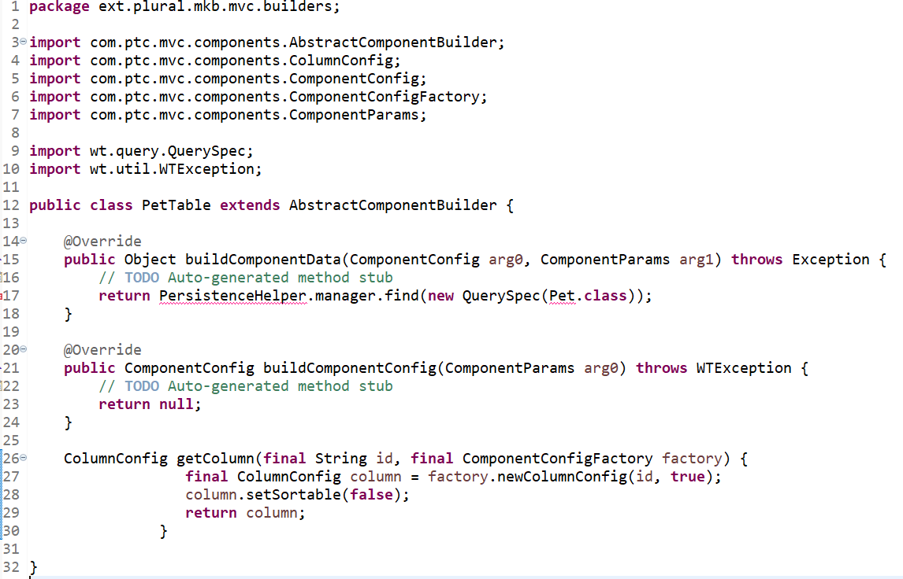

4. Next, create a new class, mkbManagerResource, to manage the localized display name of the table. The complete listing follows:

package ext.plural.mkb.jca;
import wt.util.resource.*;
@RBUUID("com.acme.jca.mkbActionResource")
public final class mkbManagerResource extends WTListResourceBundle {
@RBEntry("Pets")
public static final String PET_TABLE_LABEL = "pet_table_label";
}
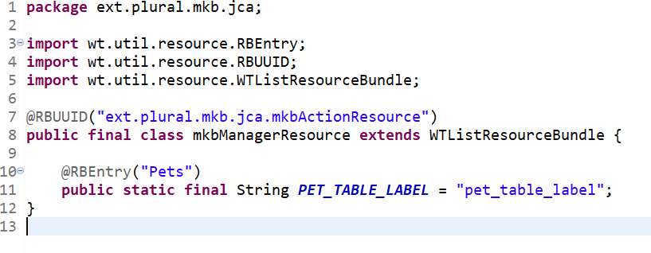

5. Next, replace buildComponentConfig’s generated body with ():

final ComponentConfigFactory factory = getComponentConfigFactory();
final TableConfig table; {
table = factory.newTableConfig();
table.setType(Pet.class.getName());
table.setLabel(WTMessage.getLocalizedMessage(RESOURCE,
acmeManagerResource.PET_TABLE_LABEL, null));
table.setSelectable(true);
table.setShowCount(true);
table.setShowCustomViewLink(false);
final ColumnConfig name; {
name = factory.newColumnConfig(Pet.NAME, true);
name.setInfoPageLink(true);
name.setSortable(true);
}
table.addComponent(name);
table.addComponent(getColumn(ColumnIdentifiers.INFO_ACTION, factory));
table.addComponent(getColumn(ColumnIdentifiers.NM_ACTIONS, factory));
table.addComponent(getColumn(ColumnIdentifiers.LAST_MODIFIED, factory));
table.addComponent(getColumn(Pet.KIND, factory));
table.addComponent(getColumn(Pet.DATE_OF_BIRTH, factory));
table.addComponent(getColumn(Pet.FIXED, factory));
}
return table;

Use Control-L to resolve classes as follows: ext.plural.mkb.jca.mkbManagerResource, com.ptc.core.components.descriptor.DescriptorConstants.ColumnIdentifiers, com.ptc.mvc.components.TableConfig, and wt.util.WTMessage. Also, assign RESOURCE as a field:

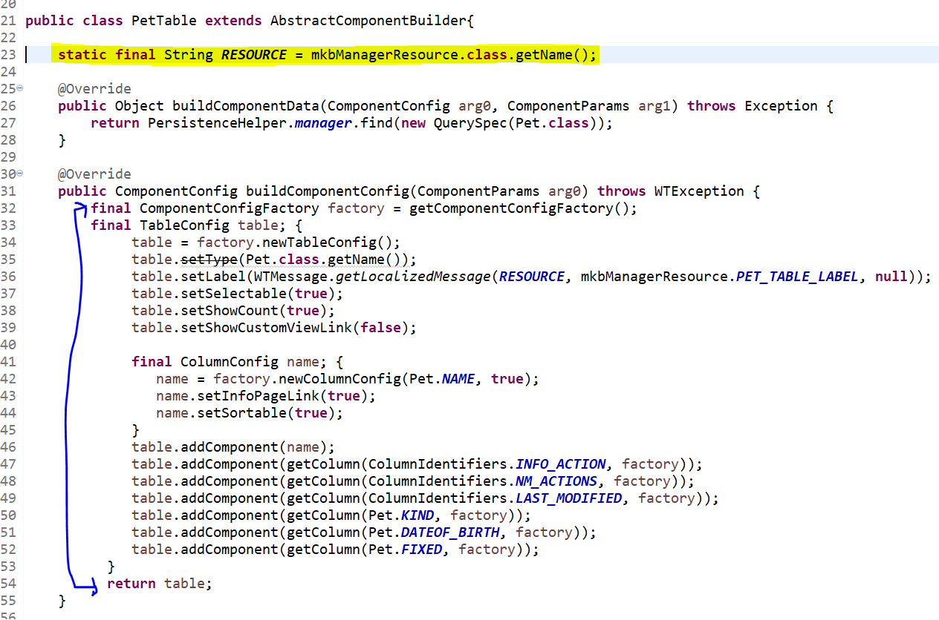

6. Register PetTable as a bean
a. Annotate the PetTable class declaration as follows: @ComponentBuilder("mkb.pet.table")
b. Alter the project’s exclusions:

a. Make the project’s .classpath (eclipse/cust_Windchill_src/.classpath) writeable
b. Project > Properties
c. Select Java Build Path and the Source tab.
d. Select Excluded under cust_Windchil_src/src and select Edit.
e. Select config/** and select Edit.
f. Replace config/** with config/logicrepository/** and click OK
g. Click Finish and OK

7. Create a new file named Pet-configs.xml.
a. simply create a General -> File
b. Assign parent folder to cust_Windchill_src/src/config/mvc and file name to Pet-configs.xml and click Finish.
c. Content is as follows:
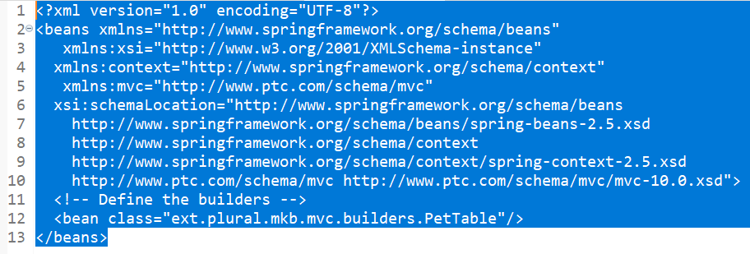

8. Validate that the table works by starting/restarting Windchill and appending to the base Windchill URL /app/#ptc1/comp/mkb.pet.table. The following table should appear:
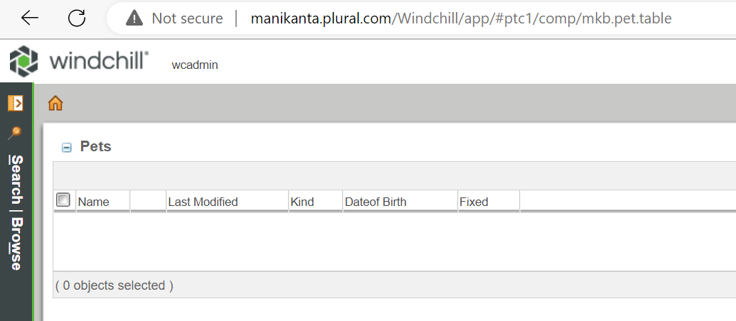

Errors: If the method server fails to start with the error “Infor resource not found” then follow the below article.
Article - CS129745 - Method Server fails to start with error wt.introspection.InfoNotFoundException: Info resource not found for &lt;classname&gt; in Windchill PDMLink (ptc.com)
Then again compile all the java classes, clean cache and restart Windchill.

Pet Information Page

Wiring the Pet table into Site > Utilities

At this point, mkb.pet.table is accessible, but requires the user to specify the URL manually. Pet is not WTContained, so a logical place to wire in the table is under Site > Utilities.

1. The site utilities or managed by codebase/netmarkets/jsp/object/commonUtilities.jspf, a Windchill-delivered and Windchill-managed file. This file should not be updated in place; rather, it should be handled by the “safe area” mechanism.
a. Create the following two directory structures under load point:
▪ wtSafeArea/ptcOrig/codebase/netmarkets/jsp/object
▪ wtSafeArea/siteMod/codebase/netmarkets/jsp/object
Copy commonUtilities.jspf to both directories just created above.
2. Edit wtSafeArea/siteMod/codebase/netmarkets/jsp/object as follows to add the items in bold:
a. After <%@ page import="com.ptc.netmarkets.object.objectResource"%> add: <%@ page import=" ext.plural.mkb.mkbResource"%>

b. After private static final String ENTERPRISE_RESOURCE = "wt.enterprise.enterpriseResource"; add private static final String MKB_RESOURCE = "ext.plural.mkb.mkbResource";

c. After ResourceBundle enterpriseRb = ResourceBundle.getBundle(ENTERPRISE_RESOURCE, localeBean.getLocale()); add ResourceBundle mkbRb = ResourceBundle.getBundle(MKB_RESOURCE, localeBean.getLocale());

- After "PERSONAL_CABINETS” , add "PET_ADMINISTRATION"

- After the if (wvs_enabled ) { block add
linkDatum.put("PET_ADMINISTRATION.isUtilityInstalled", "Yes");
linkDatum.put("PET_ADMINISTRATION.isMKBUtility", "Yes");
linkDatum.put("PET_ADMINISTRATION.idText" , linkBean.getLinkID(null,"textLink:petAdmin") );
linkDatum.put("PET_ADMINISTRATION.pageLoc", NetmarketURL.convertToShellURL("ptc1/comp/mkb.pet.table"));
linkDatum.put("PET_ADMINISTRATION.urlPrarms"
,"'PetAdmin','resizable=yes,scrollbars=yes,menubar=yes,
toolbar=yes,
location=yes,status=yes'" );
linkDatum.put("PET_ADMINISTRATION.linkText"
,acmeRb.getString(mkbResource.PET_ADMINISTRATION));
linkDatum.put("PET_ADMINISTRATION.linkDesc"
,acmeRb.getString(mkbResource.PET_ADMINISTRATION_DESCRIPTION));
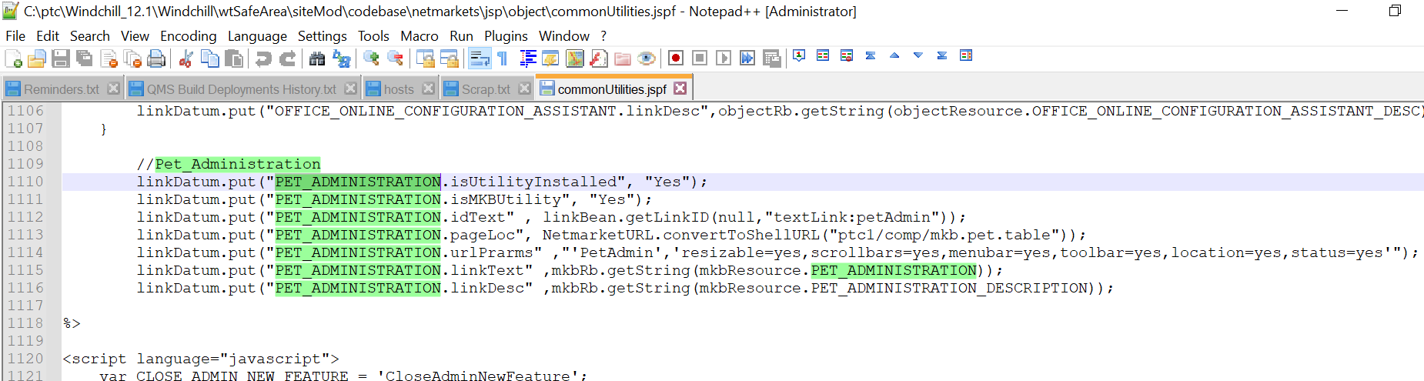
- Update the below lines
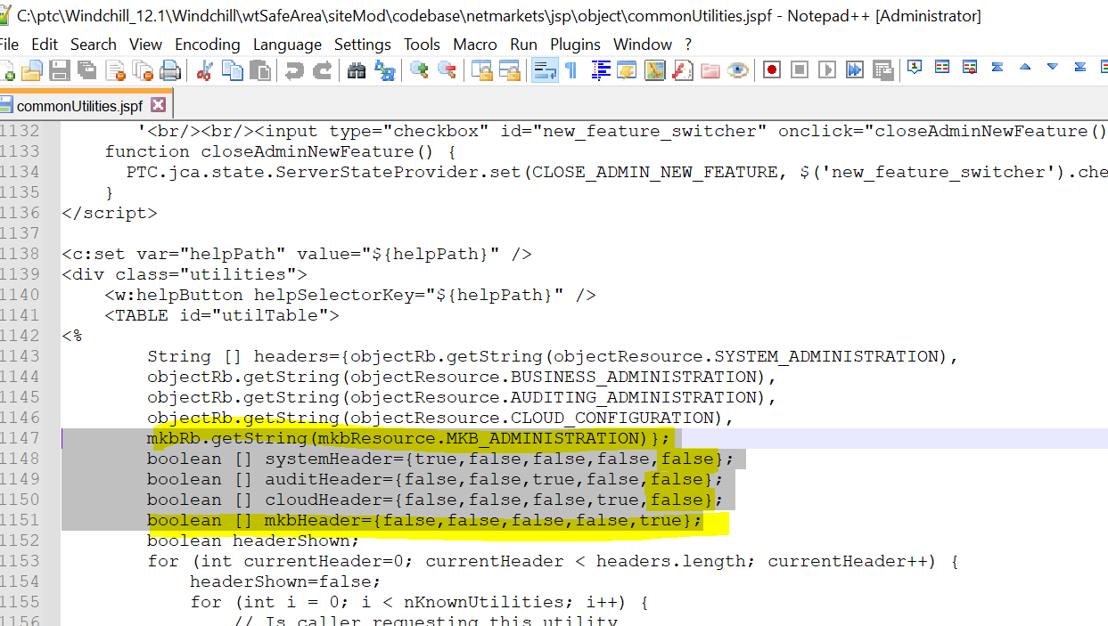

- After the //Match audit/nonaudit section add the below section.

//Match mkb/nomkb
String isMKB = knownUtilities[i].concat(".isMKBUtility");
if (linkDatum.containsKey(isMKB)!=mkbHeader[currentHeader]) {
continue;
}
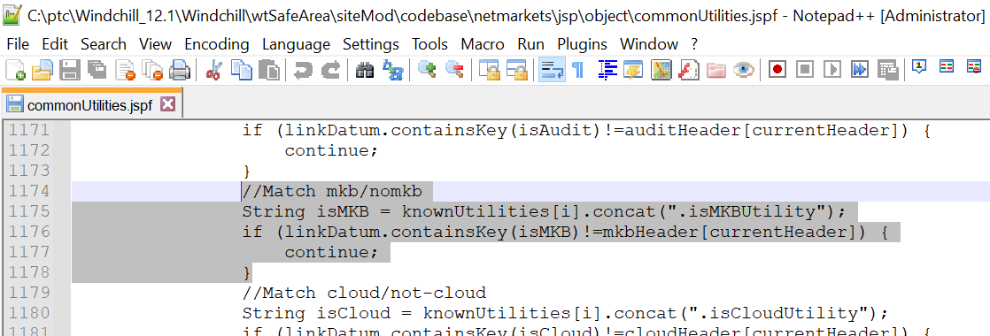

- Add the below code as shown below.
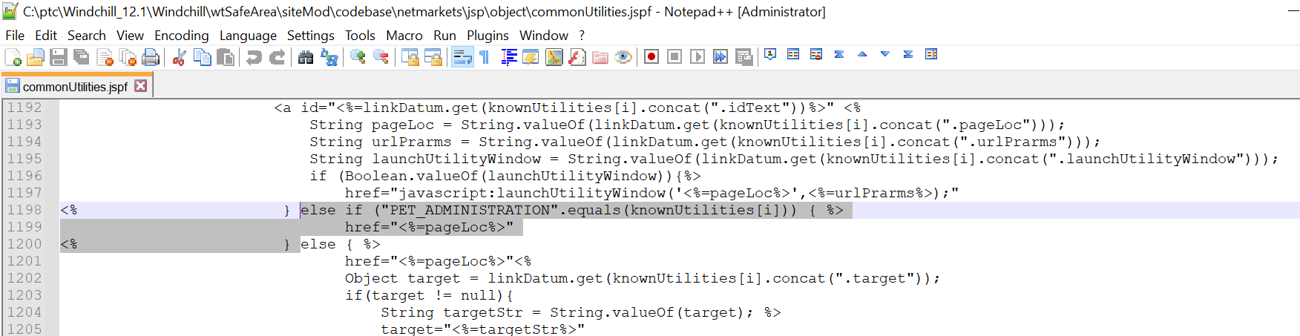

3. Enable PET_ADMINISTRATION
a. Create the following two directory structures under load point:
wtSafeArea/ptcOrig/codebase/netmarkets/jsp/site
wtSafeArea/siteMod/codebase/netmarkets/jsp/site
b. Copy listUtilities.jspf to both directories just created above.

c. Edit wtSafeArea/siteMod/codebase/netmarkets/jsp/site/listUtilities.jsp and append the below line
showUtility.put("PET_ADMINISTRATION" , "Enable");
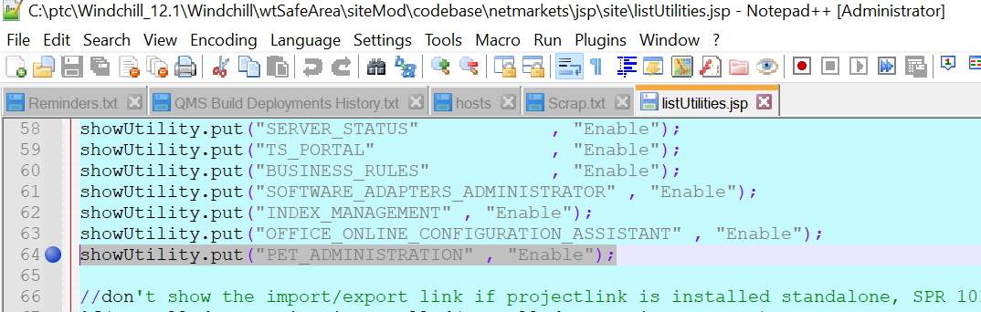

4. Deploy the site modifications: ant -f bin/swmaint.xml installSiteChanges

5. Create the imported mkbResource as shown.
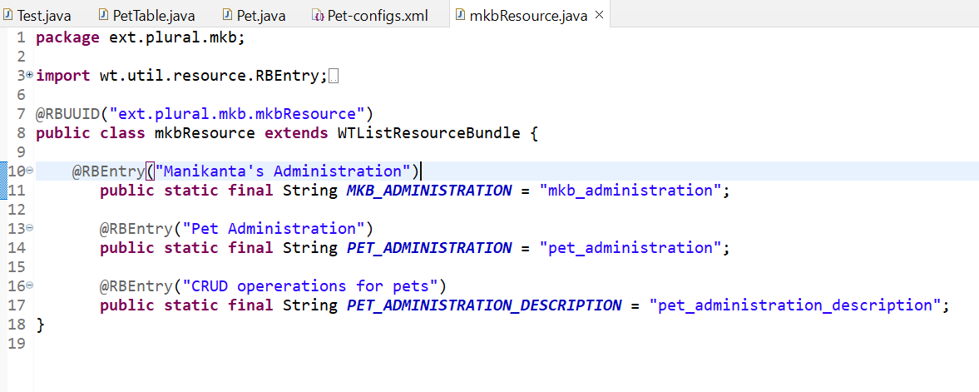
6. Start/restart Windchill.
7. Site > Utilities should incorporate Manikanta’s Administration, as shown.
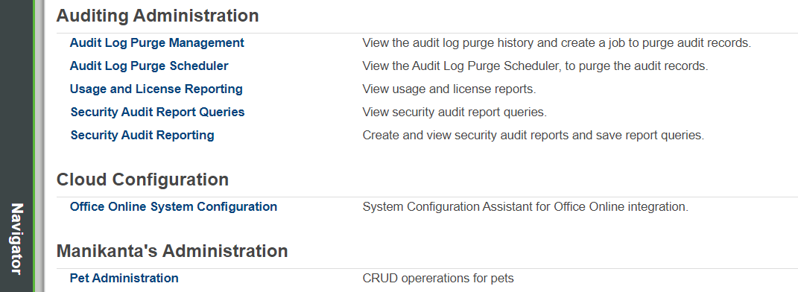

Pet Information Page

The table currently shows an “i” for an info page, but the information page has not been created yet (clicking the “i” will result in an error).
1. Create the primary builder for the information page. Complete source follows:
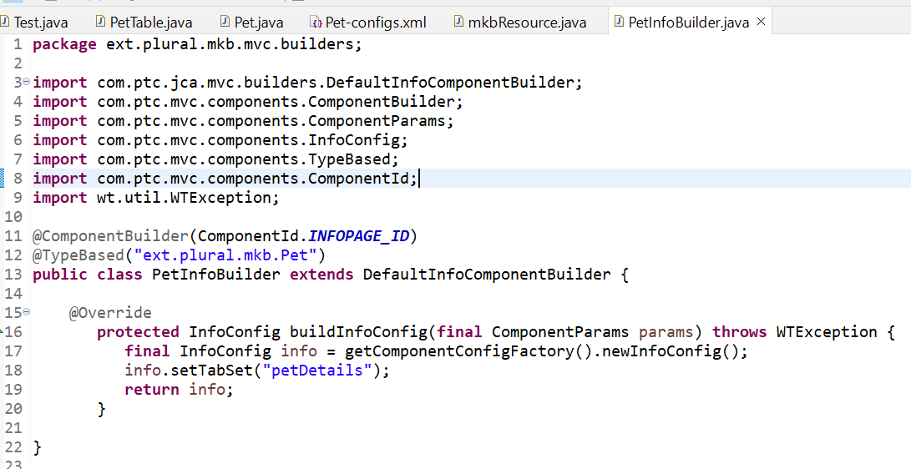

2. Define the petDetails tab set by creating its action model (in config/actions/Pet-actionmodels.xml).
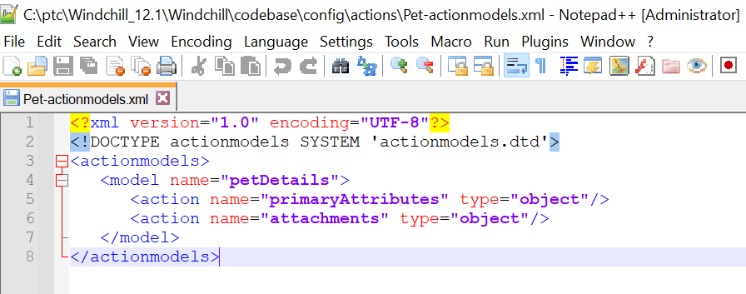

3. Define the primaryAttributes.
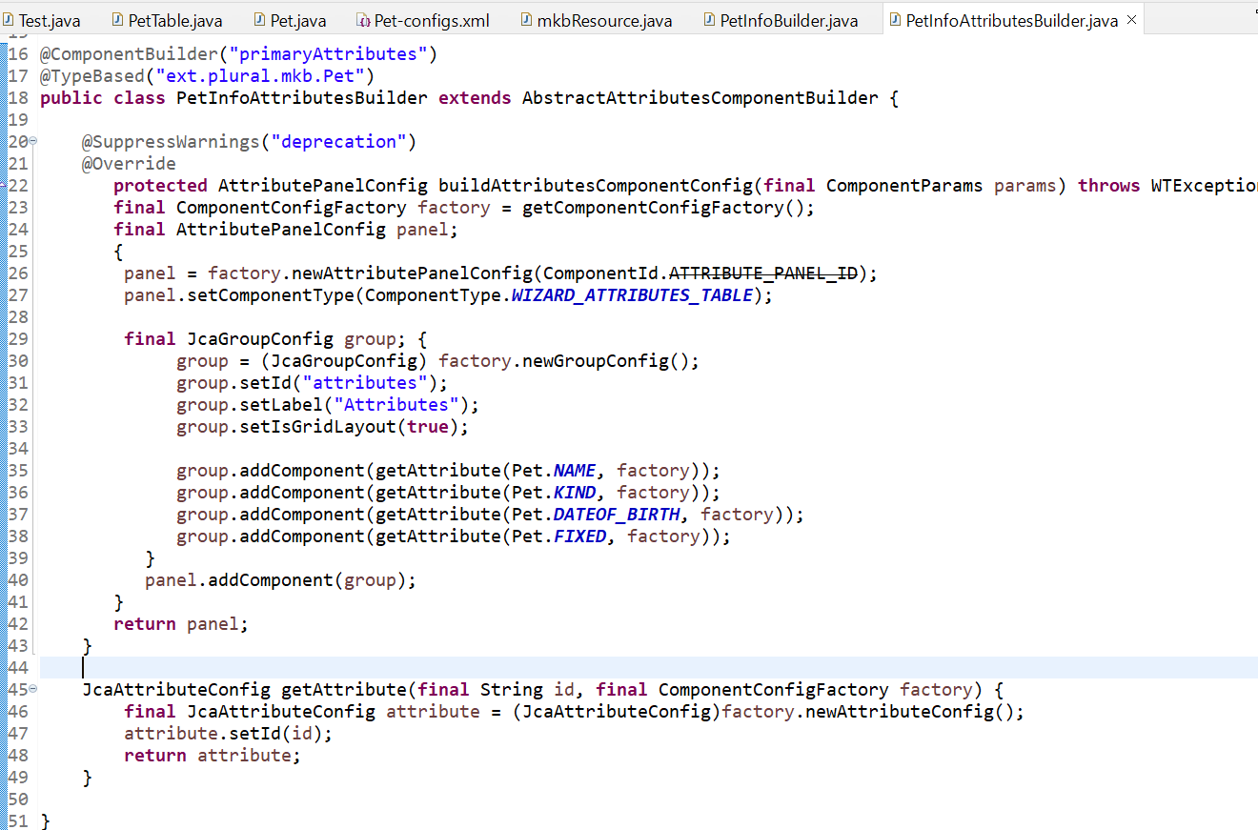

4. Register the beans by updating Pet-configs.xml to include:
<bean class="ext.plural.mkb.mvc.builders.PetInfoBuilder"/>
<bean class=" ext.plural.mkb.mvc.builders.PetInfoAttributesBuilder"/>

5. Add Pet-actionmodels.xml to site.xconf.
a. Just before the last line, </Configuration> add
<AddToProperty name="com.ptc.netmarkets.util.misc.defaultActionmodels" value="config/actions/Petactionmodels.xml"/>

b. Run bin/xconfmanager -p to propagate the change.

6. Start/restart Windchill and verify (noting the Attachments tab for content).

Creating a New Pet

Creating a new Pet involves building a dialog for it and making it visible on the table.
1. Create create.jsp, a wizard for creating pets.
a. create a general file (Other... > General > File)
b. The folder is cust_Windchill_src/src/netmarkets/jsp/mkb/pet, file name is create.jsp.
c. Click Finish and replace content with the following:
<%@taglib prefix="jca" uri="http://www.ptc.com/windchill/taglib/components"%>
<%@taglib prefix="attachments" uri="http://www.ptc.com/windchill/taglib/attachments"%>
<%@include file="/netmarkets/jsp/components/beginWizard.jspf"%>
<%@include file="/netmarkets/jsp/components/includeWizBean.jspf"%>

<jca:initializeItem baseTypeName="ext.plural.mkb.Pet" operation="${createBean.create}" attributePopulatorClass="com.ptc.core.components.forms.DefaultAttributePopulator"/>

<jca:wizard>
<jca:wizardStep action="petDefineItemAttributesWizStep" type="pet"/>
<jca:wizardStep action="attachments_step" type="attachments"/>
</jca:wizard>

<attachments:fileSelectionAndUploadApplet/>

%@include file="/netmarkets/jsp/util/end.jspf"%

2. Define the petDefineItemAttributesWizStep action.
a. Create Pet-actions.xml alongside Pet-actionmodels.xml in config.actions.
b. Assign its content as follows:
<?xml version="1.0" encoding="UTF-8"?>
<!DOCTYPE listofactions SYSTEM 'actions.dtd'>
<listofactions>
<objecttype name="pet" class="ext.plural.mkb.Pet" resourceBundle="ext.plural.mkb.jca.mkbActionResource">
<action name="petDefineItemAttributesWizStep" afterVK="setAttributesWizStep" preloadWizardPage="true" required="true">
<command url="netmarkets/jsp/mkb/pet/defineItemAttributesWizStep.jsp" windowType="wizard_step"/>
</action>
</objecttype>
</listofactions>

c. Register Pet-actions.xml in site.xconf

- Run xconfmanager again to propagate the change.

3. Create the defineItemAttributesWizStep.jsp JSP page alongside create.jsp with the following content:
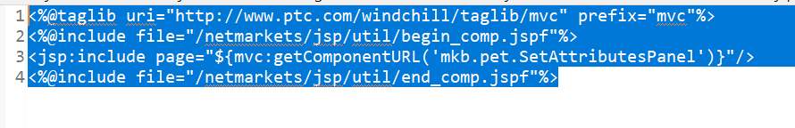

4. Define the component (mkb.pet.SetAttributesPanel)
a. Create PetSetAttributesPanelBuilder with content.
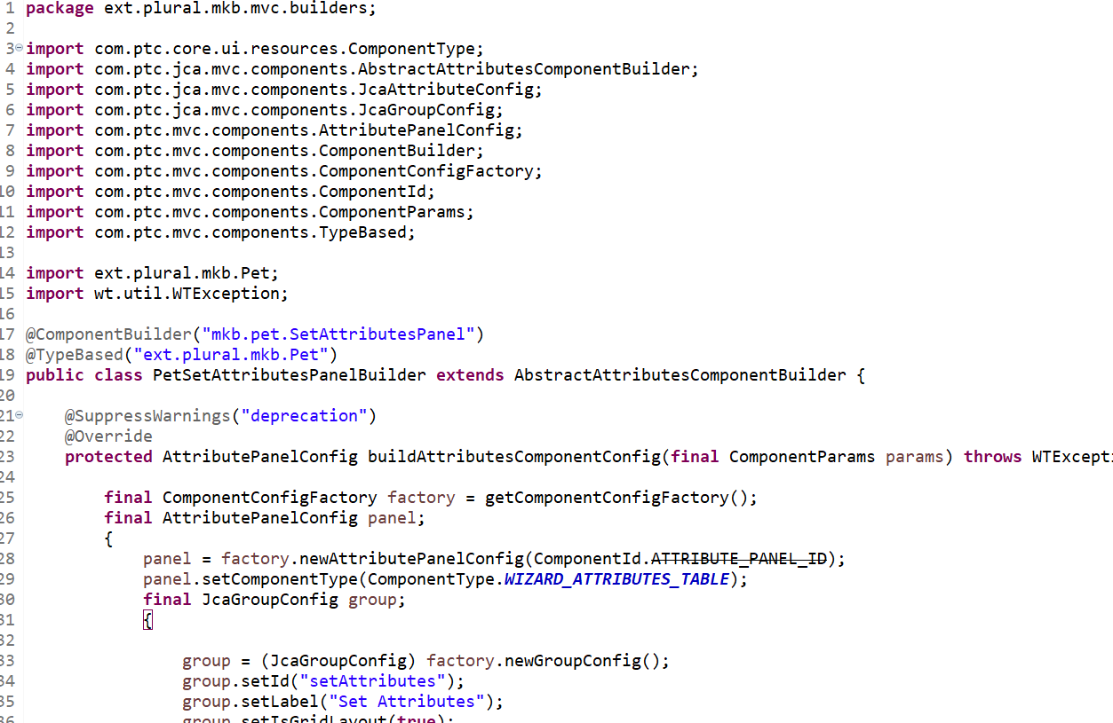

b. Add the following to Pet-configs.xml to register the builder
<bean id="mkb.pet.SetAttributesPanel" class="ext.plural.mkb.mvc.builders.PetSetAttributesPanelBuilder"/>

5. Create the resourceBundle referred to by petDefineItemAttributesWizStep, with content as follows (note the reuse of createPackage.gif as the icon for creating pets):
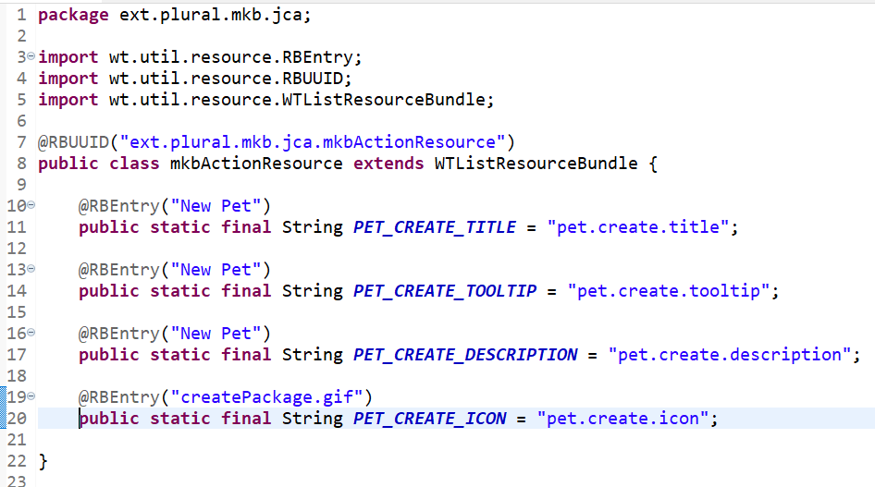

6. Wire the create action into PetTable.
a. Add the following model to Pet-actionmodels.xml (just above the petDetails model).
<model name="pets list">
<action name="create" type="pet" shortcut="true"/>
</model>
b. Add the create action to pet in Pet-actions.xml (just above petDefineItemAttributesWizStep).
<action name="create">
<command class="com.ptc.core.components.forms.CreateObjectFormProcessor" url="netmarkets/jsp/mkb/pet/create.jsp" windowType="popup"/>
</action>
c. Incorporate the action model (pets list) into PetTable (add before table.setSelectable(true);). Example: table.setActionModel("pets list");
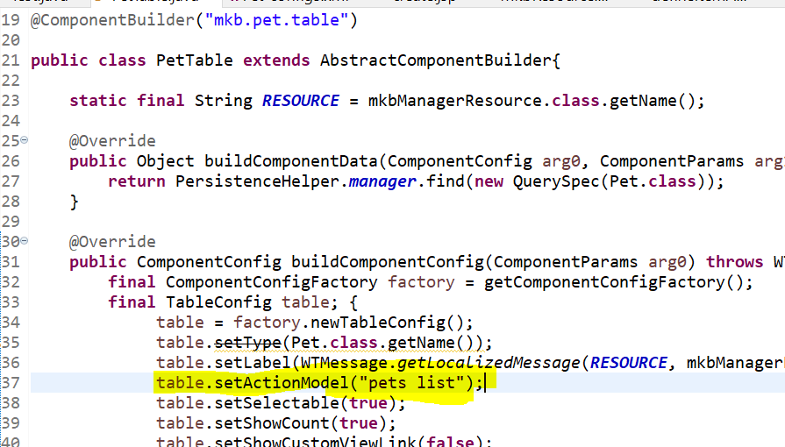

7. Also add the below property.
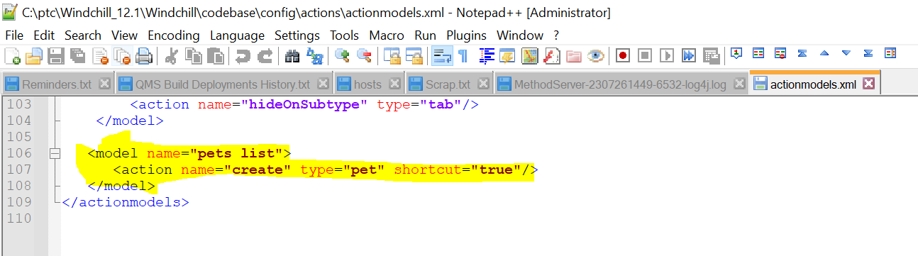
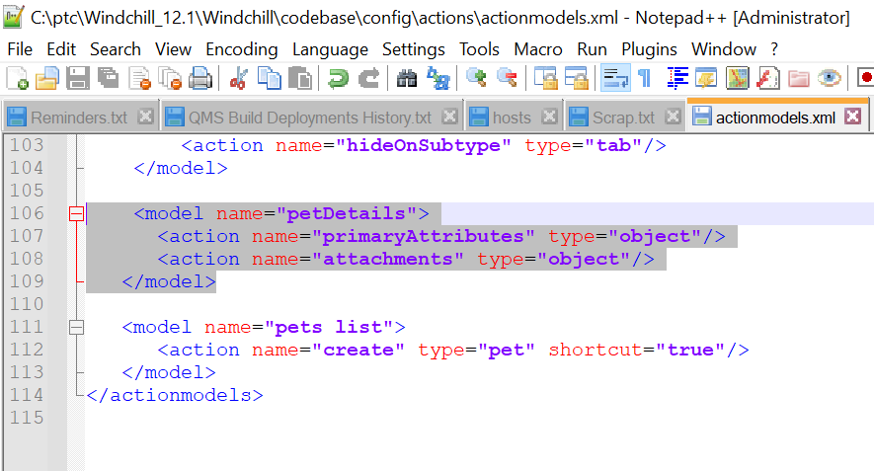

8. Also add the below property in site.xconf and execute xconfmanager as per Article-CS182343
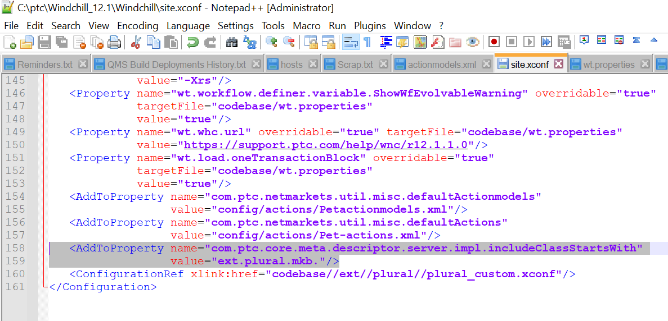

9. Start/restart Windchill.
a. Verify the New Pet icon is available on the table.
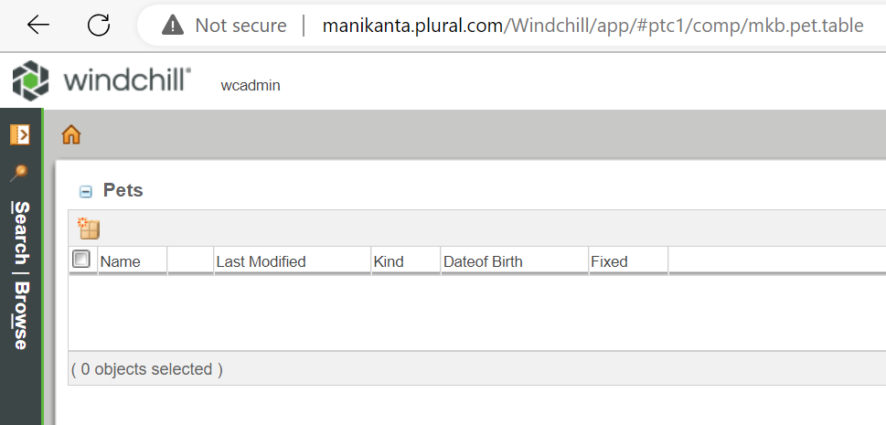

b. Click New Pet and verify a pop-up consisting of a wizard with two steps.
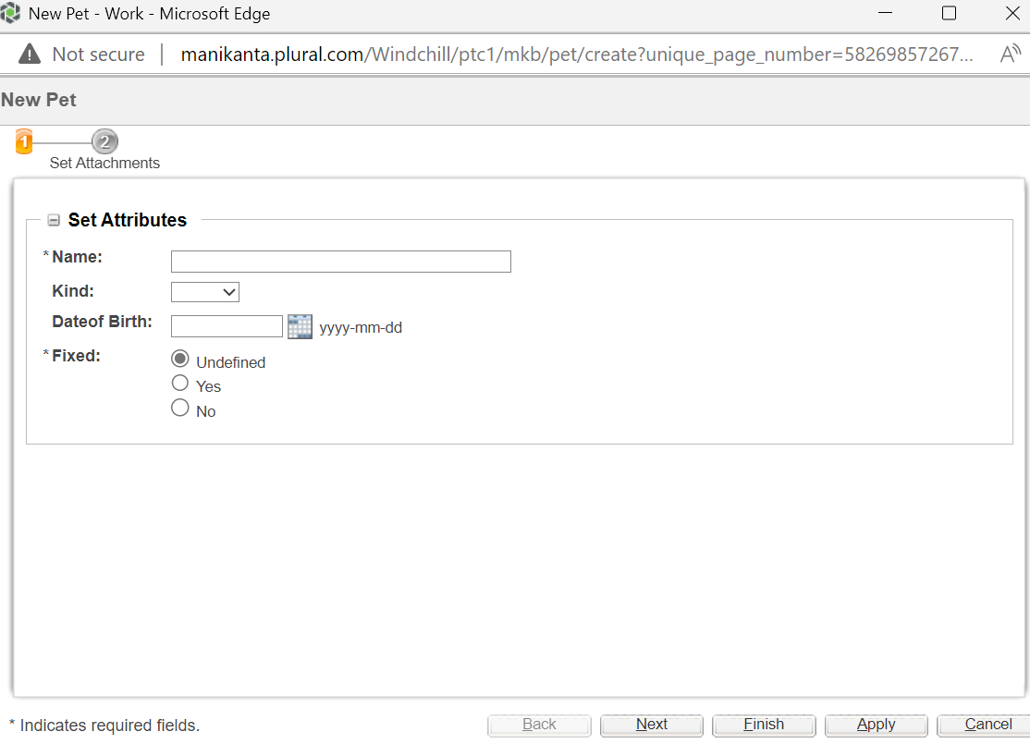

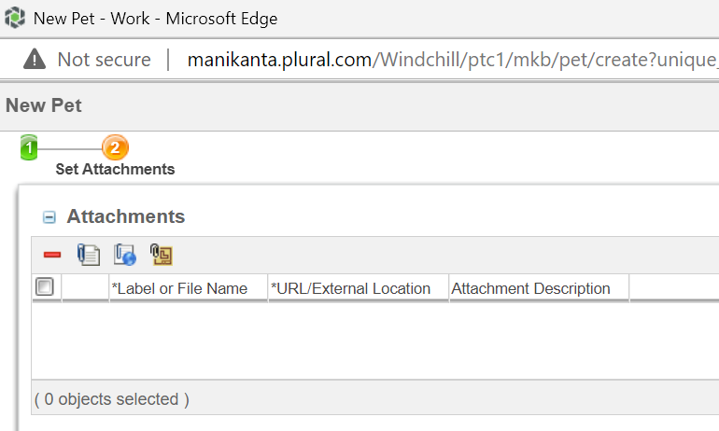
d. Create a pet. Be sure to upload the content.
When downloading the attachments observed the below issue.
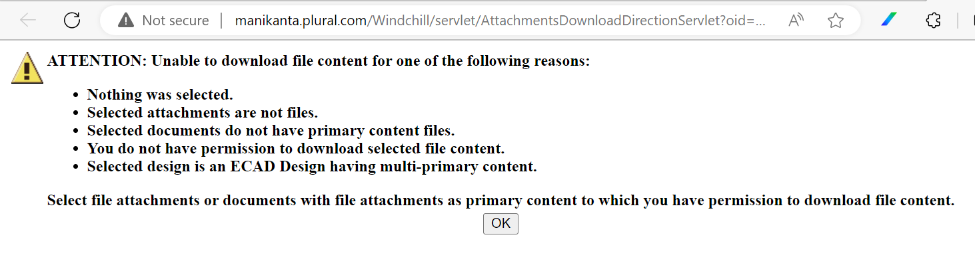

Resolution:
<Will document the resolution steps once identified>

Editing Pet

The process of editing a pet is similar to the process of creating one.
1. Copy createPet.jsp
a. Select create.jsp.
b. Right-click -> Copy
c. Right-click -> Paste, set new name to editPet.jsp.
d. Open editPet.jsp and replace createBean.create with createBean.edit.

2. Register editPet and make it available on the information page.
a. Add the action to Pet-actions.xml.
<action name="editPet">
<command class="com.ptc.core.components.forms.DefaultEditFormProcessor"
url="netmarkets/jsp/mkb/pet/editPet.jsp" windowType="popup"/>
</action>
b. Add a menu to the “info” page.
<model name="pet actions" menufor="ext.plural.mkb.Pet">
<action name="editPet" type="pet"/>
</model>
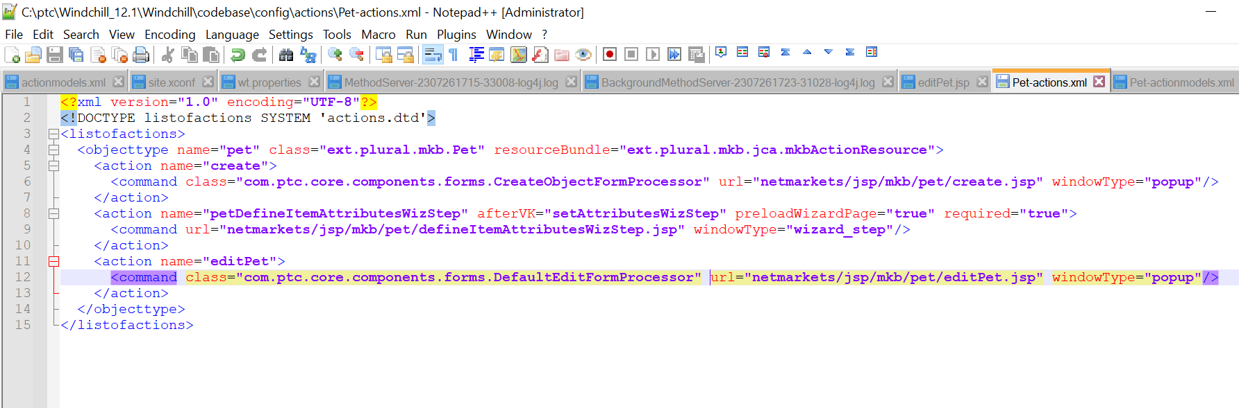
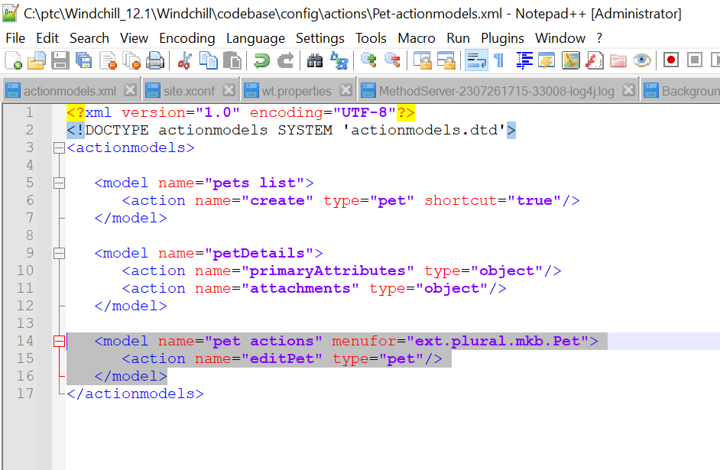
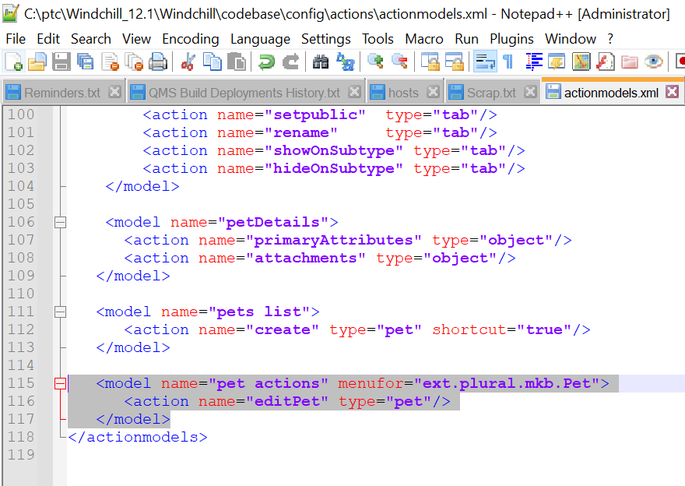

3. Add the following to mkbActionResource.java :
@RBEntry("Edit Pet")
public static final String PET_EDIT_PET_TITLE = "pet.editPet.title";
@RBEntry("Edit")
public static final String PET_EDIT_PET_TOOLTIP = "pet.editPet.tooltip";
@RBEntry("Edit")
public static final String PET_EDIT_PET_DESCRIPTION = "pet.editPet.description";
@RBEntry("edit.gif")
public static final String PET_EDIT_PET_ICON = "pet.editPet.icon";

4. Implement a wt.verification.Verifier (non-AccesControlled objects are shielded from inadvertent (or malicious) updates and deletes by a Verifier in lieu of access control)

a. Create PetVerifier with content as follows:
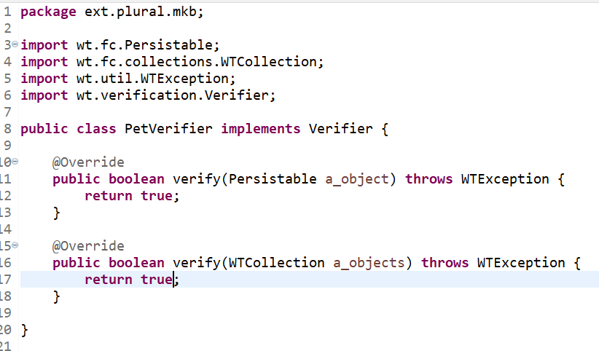

b. Register PetVerifier as a verifier for Pet by adding the following to site.xconf and propagating with xconfmanager.

5. Start/restart Windchill

Deleting a Pet
1. Under the create action of the pets list model (in Pet-actionmodels.xml), add
<action name="delete" type="object" shortcut="true"/>
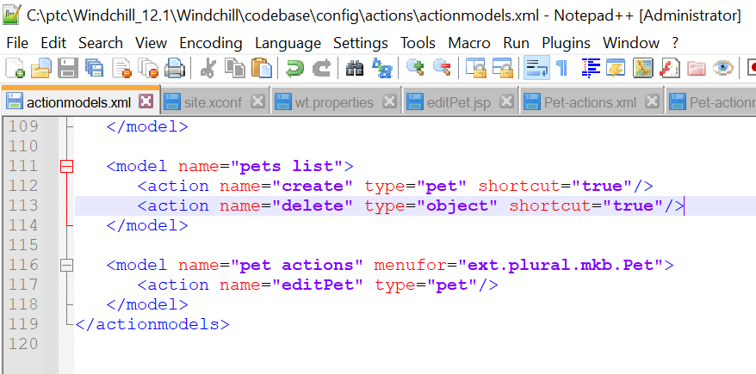
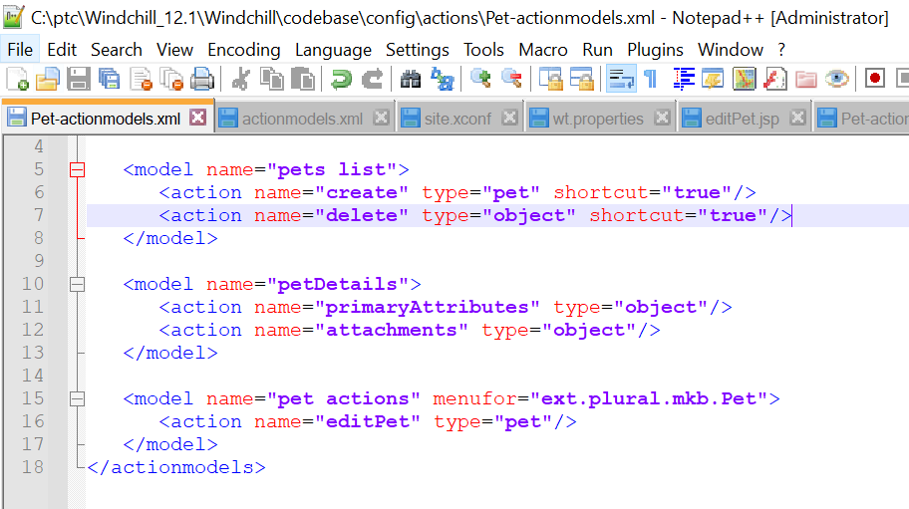

2. Start/restart Windchill.
3. Verify that “delete” has been added as an action to the pet table.
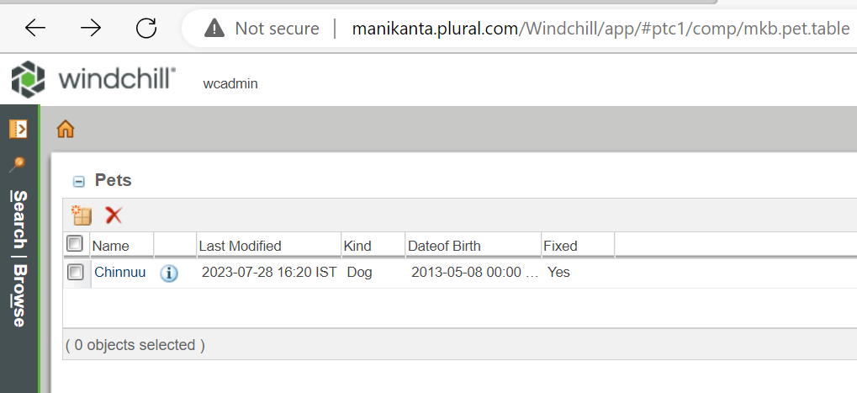

Modeling Business Objects

This chapter explains how to model business objects.

Windchill Modeling Heuristics

This section is intended to give you some background on the design of the Windchill class architecture and the approach we have used in modeling. The Windchill class architecture was designed with the following objectives in mind:
• To promote the development of business objects that reflect the characteristics of a three-tier architecture; that is, presentation for the client layer, business logic for the server layer, and persistence for the database layer.
• To ensure a model from which optimized code can be generated. The code that is generated should provide for managing the state of objects, transporting objects between the client and the server, and manipulating objects in the database.
• To provide an environment that enables value-added development. You must be able to extend the model and put new capabilities in existing objects.
One approach to achieving these objectives is to inherit functionality.
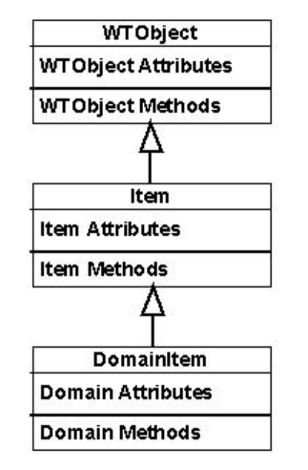

Windchill Foundation Abstractions

At an infrastructure layer of Windchill’s architecture are foundational abstractions to be used by services and applications. These abstractions, shown in the following figure, represent the fundamental types that are commonly used by others as a part of a Windchill system.

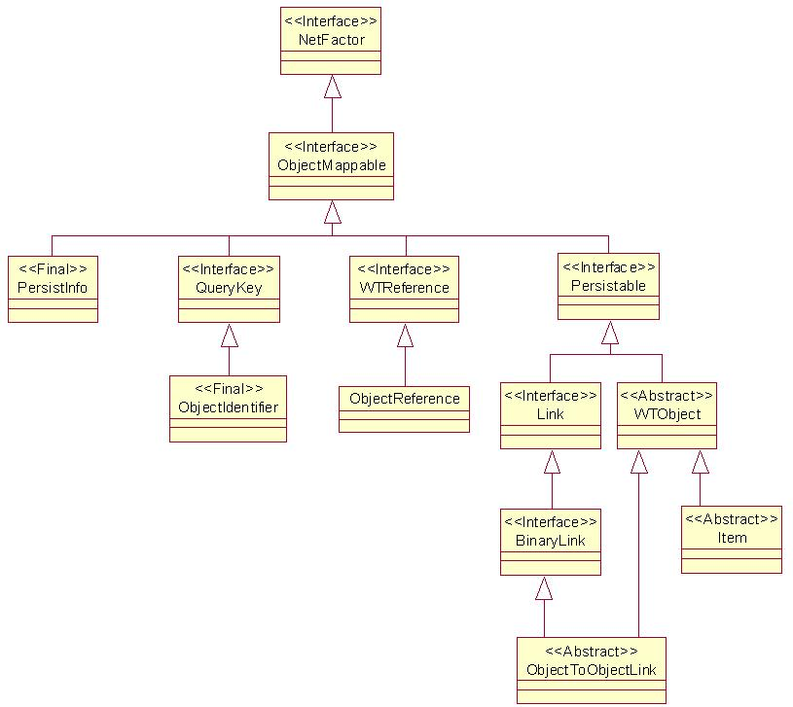

Windchill Foundation Interfaces

Note: Not required the documentation.

Windchill Foundation Classes

Windchill provides three base classes with some basic functionality for business information objects: WTObject, Item, and ObjectToObjectLink. Many business information objects provided by Windchill, and probably many that you create yourself, extend these foundation classes and, therefore, inherit attributes and methods from these classes.

• WTObject : Represents the base class for all Windchill business information classes. Item and ObjectToObjectLink are subclasses of WTObject.

• Item
: Represents a discrete business item.

• ObjectToObjectLink
: Represents a concrete binary association between two Persistable objects; that is, you can define a link between two items, between an item and a link, and between two links. Each link has a roleA side and a roleB side therefore, if you have a link, you can use it to navigate to all other objects associated with it.

Managing Customizations

This chapter describes the best practices that should be used when you are customizing files that are supplied by PTC or changing configuration settings that interact with the way PTC delivers software maintenance releases.

Setting Up a Directory Structure for Managing Customized Files and Text Tailoring

PTC recommends that you manage customized files by creating a directory structure known as the safe area. The actual directory name is <Windchill>/wtSafeArea

By using the wtSafeArea directory, you can store copies of the customized versions of PTC files where they will not be overwritten by the Windchill Service Pack installer, as well as keep versions of the original PTC files.

You can then compare the original files to those updated by PTC to identify where changes have been made.

Doing the comparison can assist you in incorporating PTC updates into your customized files.

PTC provides a script to assist with managing and installing customized files into your system runtime locations within the <Windchill> installation directory.

Additionally, if you make changes to resource bundle information files (RBINFO files), then you must use the <Windchill>/wtCustom directory structure to store those changes.

Directory Structure Diagram for Customized Files and Text Tailoring

The following diagram gives an example directory structure that includes the wtCustom directory for text tailoring and the wtSafeArea directory for other customizations. The wtSafeArea directory contains subdirectories for storing site-modified (i.e., customized) files and corresponding current versions and original versions of the files that PTC has delivered. Following the diagram are the details about how these directories are used.

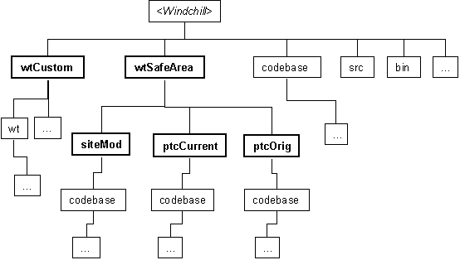

Safe Area Directory Structure

Under the wtSafeArea directory shown in the previous diagram, notice that a similar directory structure is shown for the siteMod, ptcCurrent, and ptcOrig subdirectories.

For example if the installed file <Windchill>/codebase/templates/abcx.html has been modified, then the following set of related files is located under the wtSafeArea directory:

wtSafeArea/siteMod/codebase/templates/abcx.html
wtSafeArea/ptcCurrent/codebase/templates/abcx.html
wtSafeArea/ptcOrig/codebase/templates/abcx.html
The following summary describes the purpose of each subdirectory:

siteMod -- contains the site version of each PTC file that you have modified and want to run in production.

ptcCurrent -- contains the current PTC version of the file. This is a version newer than the version in the ptcOrig directory and is copied to the directory by the Windchill Service Pack when the installer finds a corresponding file in the siteMod directory.

ptcOrig -- contains the original file from PTC. Put the version of the file in this directory before you modify it for the first time and place the customized version in the siteMod directory.

The following items describe the purpose and processing of the files under each of the subdirectories in more detail:

• siteMod
◦ Under this directory structure, store the site version of PTC files that you modify and want to run in production

◦ When running the Windchill Service Pack installer, selecting the Complete installation type option directs the installer to copy files from the siteMod directories to the selected installation directory. The files that are copied overwrite existing files in the installation directory. The actual file copying is done by the execution of the installSiteChanges target of the <Windchill>/bin/swmaint.xml Ant script.

As described in PTC Script for Working with Customized Files there are a few files that you should not put under the siteMod directory.
◦ You must place and update files in this directory yourself; the Windchill Service Pack installer does not modify the files in the directory.

◦ Although the previous diagram only shows a codebase subdirectory of siteMod, modified versions of files from other directories can also be deployed from the siteMod directory. For example, you can add a tasks directory under the siteMod directory and in that directory, store customized WindchillInfo*Engine tasks.

• ptcCurrent

◦ This directory structure holds the most current PTC versions of files you have modified (as identified by the presence of those files under the siteMod directory).

◦ Windchill Service Pack installer automatically places files in this directory when the following things are true:
▪ The siteMod directory exists.
▪ There are files in the siteMod directory that are being updated by the service pack installer.

The files copied to the ptcCurrent directory are the files in the service pack that have the same name as files found in the siteMod directory. Instead of copying these files to your installation directory, the files are put in the ptcCurrent directory. This means that your customized files are not overwritten by the updated PTC files.

After running the service pack installer (using any of the installation types), this directory contains updated PTC versions of the set of files that have been modified at your site.

◦ A file appears in the ptcCurrent directory when PTC delivers an updated version in a maintenance release, but only after you initially create your customized version in the siteMod directory.

• ptcOrig
◦ Before making first-time modifications to a file, put a copy of the original PTC file in this directory. The original PTC file is the last version of the file that PTC delivered prior to making modifications. This file could be the file supplied in a major release or in one of the maintenance releases.
◦ You must place files in this directory yourself; the Windchill Service Pack installer does not modify the files in the directory.
◦ ptcOrig is a suggested directory name; there are no PTC tools that actually look for this name.

After setting up this directory structure and installing updated files, you can compare the most recent version of a file from PTC (located in the ptcCurrent directory) with the currently deployed file (located in the siteMod directory) and the original version of the file (located in the ptcOrig directory). From the comparisons, you can determine how the version in the siteMod directory should be updated to incorporate the latest changes from PTC.

Text Tailoring Directory Structure
Store your updates to PTC-supplied RBINFO files in the wtCustom directory shown in Directory Structure Diagram for Customized Files and Text Tailoring. The details on which files can be updated and how to do the updates are in Best Practices for Customizing Files Supplied by PTC.

PTC Script for Working with Customized Files

PTC provides the swmaint.xml Ant script to help you manage the files in the <Windchill>/wtSafeArea/siteMod directory. The swmaint.xml script is installed in the <Windchill>/bin directory during Windchill Services installation.
To obtain a list of all swmaint.xml script target options, enter the following ant command from a Windchill shell:
ant -f bin/swmaint.xml -projecthelp

Following is a list of the most common target options:

• createSafeArea -- creates the <Windchill>/wtSafeArea/siteMod, <Windchill>/wtSafeArea/ptcCurrent, and <Windchill>/wtSafeArea/ptcOrig directories.
• listSiteChanges -- lists the files in the siteMod directory.

• installSiteChanges -- copies the files under the <Windchill>/wtSafeArea/siteMod directories to their corresponding <Windchill> installation directories. The timestamps on files from the siteMod directory are preserved when the copying is done.

There are a few files and directories that could be present under wtSafeArea/siteMod but are not copied. For example, the files under the following wtSafeArea/siteMod directory structures are not copied to installation directories:
.xconf-backup
installer
logs
codebase/instreg
tasks/codebase
temp
vaults
wtCustom
wtSafeArea

Most of these directories contain files that you should never modify; therefore, the directories should not be in the wtSafeArea/siteMod directory. If you happen to have files in any of these directories, the target reports that the files were not copied.

The following files in the wtSafeArea/siteMod directory structure are also not copied to installation directories:

bin/swmaint.xml
codebase/.xconf-target-file-hints
declarations.xconf
site.xconf

For an up-to-date list of files and directory structures excluded when the installSiteChanges target option is processed, see the output from the listSiteModExclusions target option.

• listSiteModExclusions -- lists the files and directory tree structure patterns of those files and directories that are excluded when the installSiteChanges target option is processed.

• listSiteChangesIgnored -- lists the files under the <Windchill>/wtSafeArea/siteMod directory that are not copied to corresponding <Windchill> installation directories when you run installSiteChanges. This target option is also run when you run the swmaint.xml script with the listSiteModExclusions target option.

• MakeJar.xml -- a script to build JAR files and maintain a network of definition files for building jar files.

Using the Safe Area Directory Structure When Customizing Files

The following descriptions assume that you have set up your safe area directory structure, as described in Directory Structure Diagram for Customized Files and Text Tailoring.

Use the following procedure to modify a PTC file for the first time:
1. Copy the original version of the PTC file into the proper subdirectory under the ptcOrig directory. For example, copy:
<Windchill>/codebase/templates/adcx.html
to:
<Windchill>/wtSafeArea/ptcOrig/codebase/templates/abcx.html.
2. Also copy the file to the siteMod directory and then make your modifications to the file that is in the siteMod directory. For example, copy the abcx.html file as follows and then modify the copied file:
<Windchill>/wtSafeArea/siteMod/codebase/templates/abcx.html.
3. When you are ready to use the customized files in your <Windchill> installation directory, copy the customized files into the installation directory.
Run the following swmaint.xml script from a Windchill shell to complete this step:
ant -f bin/swmaint.xml installSiteChanges

Using the Safe Area Directory Structure When Installing the Windchill Service Pack

Use the following procedure to incorporate updates at a maintenance release:
1. Run the Windchill Service Pack installer using the Updates for Site-Modified Files to Safe Area installation type. Using this option puts the updated PTC versions of customized files in the ptcCurrent directory. (A file is copied into the ptcCurrent directory only if the file exists in the siteMod directory.)
2. Using the three versions of the file found in the siteMod, ptcOrig, and ptcCurrent directories, determine what changes PTC has made in this maintenance release to each of your customized files.
3. Update each filed that is in the siteMod directory appropriately.
4. After all files in the siteMod directory have been updated, run the following swmaint.xml script from a Windchill shell to copy the files into place for testing.
ant -f bin/swmaint.xml installSiteChanges
Running this target also lists all files that are not copied. Normally, there should be no files listed. Inspect any files listed to determine why they were not copied. If they were in the wrong directory, put them in the correct directory and rerun the script.

Best Practices for Customizing Files Supplied by PTC

Changing Displayed Text Found in RBINFO Files

• Site changes to PTC text values should be stored in RBINFO files that are in the <Windchill>/wtCustom directory structure. Never edit the RBINFO files in the <Windchill>/src directory. When the enumCustomize tool is used, it creates the required wtCustom directory structure.

Details on Tailoring Text

The text that is displayed in most of the user interface, be it HTML or Java-based UIs and regardless of the locale, is produced from text stored in RBINFO files.

The files installed to the directory <Windchill>/src contain PTC text, site changes to the displayed text are to be done to corresponding files in the <Windchill>/wtCustom directory.

There is a clear structure relationship between RBINFO files in the <Windchill>/wtCustom directory, the <Windchill>/src and the <Windchill>/codebase directory.

For example, the list of valid life cycle states are stored as compiled resources in <Windchill>/codebase/wt/lifecycle/StateRB*, original PTC sources are in <Windchill>/src/wt/lifecycle/StateRB*.rbInfo, and any site modifications must be stored at <Windchill>/wtCustom/wt/lifecycle/StateRB*.rbInfo.

The files under <Windchill>/src should never be edited. This is because these files can be overwritten during a maintenance installation, thus losing site modifications.

There are three kinds of text stored in RBINFO files. For all of these, site changes should only be done in files under the <Windchill>/wtCustom directory.

• Text for enumerations (EnumResourceInfo -- lists of values) is changed using the enumCustomize tool that is launched from <Windchill>/bin/enumCustomize. Using the enumCustomize tool creates the required files in the wtCustom directory and stores the values you replace.

• Text for many string messages, user interface (UI) buttons, and labels are declared in WTListResourceBundle classes, but they are changed by placing site-specific values in the wtCustom/wt/util/resource/resourceCustomize.rbInfo file

• Displayable text for modeled business information such as classes, attributes, relationships, and so on (MetadataResourceInfo) is changed by placing site specific values in RBINFO files in the wtCustom directory. By using a text editor, enter only the values you want to override in the files; values that you are not changing should not be included.

For your text changes to be used by the running product, they must be compiled into the codebase. Running the enumCustomize tool does this automatically, but only for EnumResourceInfo resources. However, all three kinds of resources can be compiled by using the ant script <Windchill>/bin/tools.xml and the bundle_custom target

To use this script, start a Windchill shell and execute the following command:
ant -f bin/tools.xml bundle_custom -Dbundle.input=registry
Both the Windchill Service Pack installer and patch installer automatically execute this command to ensure that any updates delivered by PTC are merged with your site changes in the <Windchill>/wtCustom directory.

For text changes that are to be used by any applets, you must additionally execute the MakeJar command as follows:
ant -f <Windchill>/codebase/MakeJar.xml custUpdate

For example, if you add a life cycle state to StateRB.rbInfo, you must run the above command to see the new state in an applet such as the Lifecycle Administrator.

Managing codebase Property Files

In most cases, the property files (*.properties) in the codebase directories should only be modified by using PTC tools, and never manually edited.

There are two key points regarding property files:
• Use either the xconfmanager utility to make property file changes. Additional information on these topics is covered in the next two sections.
• When you cause a property file to be changed, you may need to update downloadable client JAR files. Make sure to consult Managing Client JAR Files.

Manipulating Property Files

Most property files should be manipulated using the xconfmanager utility.

The reason to use either of these tools is that they store the property values you set in the <Windchill>/site.xconf file. They then propagate those values to the proper *.properties files.

If a PTC maintenance update delivers changes to properties that you have changed, the xconfmanager automatically propagates the property changes stored in your site.xconf file on top of the PTC updates.

The following codebase properties should not be manipulated with the xconfmanager Utility:
• associationRegistry.properties
• descendentRegistry.properties
• modelRegistry.properties
• moduleRegistry.properties
• moduleDir.properties
• debug.properties
This is because these properties contain properties not suitable for the xconfmanager Utility.

If there are a lot of new properties that you need to add to a file such as wt.properties, rather than using xconfmanager Utility to set each property, consider creating your own declarative XCONF file.

In this file, you declare the properties with a targetFile of wt.properties. Then use xconfmanager Utility to install this file into the declarations.xconf file.

Using XCONF Files

The XCONF files supplied by PTC are not intended for direct editing. All *.xconf files, except <Windchill>/declarations.xconf and <Windchill>/site.xconf should be considered read-only. The declarations.xconf and site.xconf files are both manipulated by the xconfmanager Utility.

Managing HTML Templates in the <Windchill>/codebase/templates/ Directory

The HTML template files are located in the <Windchill>/codebase/templates directory. These files must be in this directory at runtime.

If you want to modify any of the files in this directory, be sure to put a copy of the corresponding PTC files (before you make any changes) in the <Windchill>/wtSafeArea/ptcOrig/codebase/templates directory.

Then modify the files and put a copy of your customized files in the <Windchill>/wtSafeArea/siteMod/codebase/templates directory.

Managing the LogicalAttributes.xml File

The LogicalAttributes.xml file is used to assign logical names to the attributes of business objects. These logical names are used to identify the attributes when configuring certain clients. For details on the format and content of the file, see the file itself and the corresponding Javadoc.
The file is located in the <Windchill>/codebase directory. To prevent overwriting, use the safe area procedures

Managing codebase/{wtcore,netmarkets,pdmlink} Files

If you have a requirement to modify any of the files, such as JSP files, under the <Windchill>/codebase/wtcore, <Windchill>/codebase/netmarkets, or <Windchill>/codebase/pdmlink directories, be aware that during a maintenance installation the PTC updates to the same files could overwrite your changes.
To prevent overwriting, you should utilize the safe area procedures

Managing Windchill Info Engine Tasks

WindchillInfo*Engine tasks are stored in the <Windchill>/tasks directory. If you customize any of the task files, they could be overwritten during a maintenance installation if PTC must update the same task files.
To prevent overwriting modified tasks, you should utilize the safe area procedures

INI Files for Workgroup Manager

If you modify any INI files for the workgroup managers, then you should copy the originals to the ptcOrig directory and put your modified versions in the siteMod directory.

Managing Client JAR Files

Note: Nothing was found to be useful for customization

Most client JARs are maintained through the use of an Ant script, MakeJar.xml, provided with Windchill.

To ensure that the JAR files maintained through the MakeJar.xml script are updated correctly, you should add the following to the <Windchill>/codebase/jarContents/Cust.bom:
• Paths for the compiled resources (*.ser and/or *.class files) of the files you change
• Paths of customized property files

To verify that all customized property files are listed in Cust.bom, you can compare targetFile entries in site.xconf with the files listed in Cust.bom. Any files listed in targetFile entries that are not in Cust.bom should be added to Cust.bom. For example, if the site.xconf file has an entry for the following:
targetFile="codebase/wt/change2/change2.properties"
Then, ensure that codebase/jarContents/Cust.bom contains the following entry:
wt/change2/change2.properties

To rebuild the client JAR files that are managed by jarContents and jarManifest specifications, execute the following command from a Windchill shell:
ant -f codebase/MakeJar.xml custUpdate

Overview of Client JAR Deployment Approach
Note: Theory was out of my understanding range

Current Foundation JAR Tree Definition
Note: Theory was out of my understanding range

Using the Client JAR Architecture

Rebuilding Client JARs
To rebuild all of the new client JARs, one can simply type:
ant -f MakeJar.xml
from a command prompt in the <Windchill>/codebase directory.

To obtain more information on these targets, execute the following command:
ant -f MakeJar.xml -projecthelp

Managing Client JAR Contents
Not required the documentation

Using the HTTP Request Log Utility
Not required the documentation

Re-using an Existing Root JAR
Not required the documentation

Updating Client JARs At Maintenance Releases
Not required the documentation

Handling Localized Resources
Not required the documentation

Best Practices for Adding New Packages and Files

You can store new packages and files under the <Windchill>/src/directory structure; however, the packages and files that are defined should not be stored under the <Windchill>/src/wt or <Windchill>/src/com/ptc directory.

Typically, newly developed packages and files are stored under the domain name of your company. For example if your company domain name is mycompany.com, store them under <Windchill>/src/com/mycompany.

When you create a new package, you need to add it to the includeClassStartsWith property in wt.properties. This property lists the package hierarchies that are included when resolving inherited descriptor information. For example, if you add the package com.mycompany, use xconfmanager to add “com.mycompany.” to the property, with the following command from a windchill shell:
xconfmanager --add com.ptc.core.meta.descriptor.server.impl.includeClassStartsWith=com. mycompany. -p
Make sure the package name ends with the period (".") character.

The types of files that you should store under <Windchill>/src/com/mycompany include new Java source files, property files, HTML templates, RBINFO files, and XCONF files.

In addition to keeping your new packages and files in a <Windchill>/src/com/mycompany directory structure, you must include corresponding packages and files in your runtime system. For example, the following list explains where your files should be placed:
• Java files are typically compiled to a comparable directory under <Windchill>/codebase. For example, if you create a class under <Windchill>/src/com/mycompany/part, you could compile it to <Windchill>/codebase/com/mycompany/part.
• Resource bundle files must be compiled into a directory under <Windchill>/codebase at runtime. This can be done using the ResourceBuild command. For example, if you have new RBINFO files in the directory <Windchill>/src/com/mycompany/part, you could compile them to the <Windchill>/codebase/com/mycompany/part directory by executing the following command from a windchill shell:
ResourceBuild com.mycompany.part
• Property files maintained in a custom directory like <Windchill>/src/com/mycompany must be copied to a directory in <Windchill>/codebase at runtime.

Adding a Custom Service Provider Property File

Some site customizations involve creating a new service provider property file. Service provider property files must be declared in one of the following <Windchill>/codebase/wt.properties entries:
wt.services.applicationcontext.WTServiceProviderFromProperties.customPropertyFiles
wt.services.applicationcontext.WTServiceProviderFromProperties.defaultPropertyFiles
wt.services.applicationcontext.TypeBasedServiceProviderFromProperties.defaultPropertyFiles
wt.services.applicationcontext.TypeBasedServiceProviderFromProperties.customPropertyFiles

These properties are handled in a special fashion with xconfmanager Utility. Rather than directly specifying a new property value for any of these properties, you should instead establish a new declarative XCONF file that causes your new service provider file to be used. A key benefit to doing this is that it will avoid conflicts with these property values if you later install other PTC products that require their own service provider property values. This is illustrated with the following example.
Suppose your new service provider file name is named codebase/ext/sitepart/sitepart.properties. It contains the entries that define your new services. In order to get this property listed as one of the files in the following wt.properties entry:
wt.services.applicationcontext.WTServiceProviderFromProperties.customProp
ertyFiles
You should create a new declarative XCONF file, for example, codebase/ext/sitepart/sitepart.xconf. It would look like the following:
<?xml version="1.0" encoding="utf-8"?>
<!DOCTYPE Configuration SYSTEM "xconf.dtd">
<Configuration targetFile="codebase/wt.properties">
<!-- Ensure that the file ext/sitepart/sitepart.properties is
appended to the list of custom property files.
-->
<Property default="ext/sitepart/sitepart.properties" name="wt.services
applicationcontext.WTServiceProviderFromProperties.customPropertyFiles"/>
</Configuration>
The Property statement (formatted on two lines for this guide) is one line in the file that declares that the file ext/sitepart/sitepart.properties (a path relative to the codebase directory) should be added as a value for the property:
wt.services.applicationcontext.WTServiceProviderFromProperties.customProp
ertyFiles
This property is in the codebase/wt.properties file.

Store a copy of new XCONF files in your source directories as described in Best Practices for Customizing Files Supplied by PTC.
To install the codebase/ext/sitepart/sitepart.xconf file and generate the sitepart.properties file, execute the xconfmanager Utility from a windchill shell, as follows:
xconfmanager -i codebase/ext/sitepart/sitepart.xconf -p
After running the above command, the wt.properties file is updated to reference your service provider file, codebase/ext/sitepart/sitepart.properties.
Compiling Custom Classes
The syntax to compile custom java classes to the Windchill codebase is: ant -f bin/tools.xml class -Dclass.includes=*.java -Dclass.source=<Windchill>/wtCustom/<custom-subdirectories>

Monitoring a Customized Windchill Environment
Documentation is not required

Customization with Windchill Queues

Windchill queues provide a means of scheduling lower priority work which can be run in the background. Many of the OOTB Windchill services create and use queues for lower priority work activities. These capabilities are available to user customizations also.

As part of ongoing efforts to make Windchill more secure and robust access control checks have been added to all public queue APIs. What this means for all future customizations (that use queues) is that all calls to the Queue Service must first either set Administrator, or bypass access control. Failure to do so will result in a not authorized exception being thrown.

Sample Code
The following code pattern should be followed when setting Administrator:
SessionContext previous = SessionContext.newSessionContext();
try {
SessionHelper.manager.setAdministrator();
// make calls to Queue Service
}
finally {
SessionContext.setContext(previous);
}
The following code pattern should be followed when bypassing access control:
boolean previous = SessionServerHelper.manager.setAccessEnforce(false);
try {
// make calls to Queue Service
}
finally {
SessionServerHelper.manager.setAccessEnforce(previous);
}

Windchill Utilities
This section contains information on various Windchill utilities.

Using the xconfmanager Utility

The xconfmanager is a command line utility that you can run to add, remove, or modify properties in Windchill property files.
Windchill uses some property files to manage internal system activities that you should never modify, including the following:
• associationRegistry.properties
• descendentRegistry.properties
• modelRegistry.properties
• moduleRegistry.properties
• moduleDir.properties
• debug.properties

xconfmanager Command Syntax

The syntax of xconfmanager command that administrators should use is as follows:
xconfmanager {-fFhuwvV} {-r <product_root>} {-d <property_names>} {-s
<property_pair>} {-t <property_file>} {--add <property_pair>} {--remove
<property_pair>} {--reset <property_names>} {--setfromfile <property_file>}
{--undefine <property_names>} {-i <declarative_xconf>} {--validateassite
<site_xconf>} {--validateasdecl <declarative_xconf>} {--validatefilesassite
<site_list_file>} {--validatefilesasdecl <declar_list_file>} {-p}

Parameter names are case-sensitive; enter the names using the case shown in the syntax and the following table.

The following variables are used in the syntax of multiple parameters:
• <property_pair> is a command-line escaped name=value pair that is compatible with the specification for java.util.Properties.
• <property_names> is a comma-separated list of property names.
• <property_file> is the relative or full path name of the property file.
• <declarative_xconf> is either a full URL or relative file path to the declarative XCONF file.
In the following table, all parameter names are listed in alphabetical order with corresponding parameter descriptions:
Parameter Name | Description
--add | Add the specified value at the end of the set of ordered values already defined in the property. Use this parameter only when the property is declared as a multi-valued property.  To determine if property is multi-valued, you can display the current set of values using the -d parameter. The output from this parameter lists the multivalue separator when the property is multi-valued.
-d  or  --describe | Lists the values that are currently set and the corresponding XCONF file where each value is set for the specified properties.  This parameter executes after all parameter setting options and the -p option have executed.
-F  or  --force | Forces the propagator to ignore its cache of XCONF-to-properties file dependencies and ignore the timestamp comparison it usually does to determine which property files need to be updated. Using this option propagates all site-specific changes to property files.  Use this parameter in place of -p if you suspect that there are problems with file timestamps or you want to switch between the -w and -u options.
-f  or  --forcescan | Forces the propagator to ignore its cache of XCONF-to-properties file dependencies. This parameter is ignored if you specify -F.  Use this option in place of -p if you suspect that the cache is out of date.
-h  or  --help | Displays the help for the xconfmanager command.
-i  or  --install | Installs a declarative XCONF file that you have created. New declarative XCONF files are used when creating additional property files. When you are adding code in which new properties can be set, you can choose to create a separate property file where the properties are stored.
-p  or  --propagate | Propagates all changes that have been made to XCONF files into the property files that are being used. This option always executes after any options that set properties. This execution order ensures that the newly set properties are included in the propagation.  Updated property files are accessed when the Windchill solution is restarted.
-r  or  --productroot | The root directory from which all relative paths are based for XCONF references specified in the declarations.xconf file and target file paths specified in the -t parameter.  The default root directory is the bin directory where the Windchill solution is installed.
--remove | Removes the specified value that is in the set of ordered values defined in the property. Use this option only when the property is declared as a multi-valued property.  To determine if a property is multi-valued, you can display the current set of values using the -d parameter. The output from this parameter lists the multivalue separator when the property is multi-valued.
--reset | Resets the site specific value of a property or set of properties to the declared default values.
-s  or  --set | Sets the named property to a specific value in the site.xconf file.  To set multiple properties in the same target property file, use multiple occurrences of this parameter or use the following parameter:  --setfromfile  To set multiple properties that are in different target property files, enter multiple xconfmanager commands, one for each target file.  Use this parameter in conjunction with the -t parameter.
--setfromfile | Adds the name=value pairs that are in the specified file to the end of the site.xconf file, thus setting each property named to the specified value. There is no checking done to determine if the value set is the default.  <property_file> is the file that contains a set of name=value pairs (one pair per line) that indicate the properties and values you want set in one target property file. Each pair sets a value for one property.  With this parameter, you can set multiple properties in the same target property file using one xconfmanager command. To set properties that are in different target property files, enter multiple xconfmanager commands, one for each target file.  Use this parameter in conjunction with the -t parameter.
-t  or  --targetfil | Identifies the property file in which the property value specified in the -s parameter is set or the property values specified in the following parameter are set:  --setfromfile  Use this parameter in conjunction with either the -s or the following parameter:  --setfromfile  This parameter is optional when setting common properties where the default property file to update has been declared and is available to the xconfmanager utility. For example, properties stored in wt.properties and db.properties do not require this parameter.  For other properties, you may need to specify the file path of the property file in this parameter. For example, updating properties in the federation.properties file requires that you enter this parameter using the codebase/federation.properties file path.
-u|w  or  --unix|win | Indicates the platform for which the property files are to be generated. Normally, the current platform settings determine the format of the property files.  Include this parameter when you want to generate property files for a specific platform that is not the current platform.  For UNIX platforms, specify -u or the following:  --unix  For Windows platforms, specify -w or the following:  --win
--undefine | Resets the specified properties such that their values will be null (instead of an empty string) when read through a java.util.Properties instance.
-v | Turns on verbose console output, which shows full exception stack traces.
-V | Turns on debug verbose console output. This option shows full exception stack traces and additional information.
--validateasdecl | Validates a specific file as a declarative XCONF file.  Returns a non-zero result if file cannot be validated.
--validatefilesasdecl | Validates a list of files as declarative XCONF files. The list is contained in the specified file, where each line in the file is either a full URL or relative file path to a declarative XCONF file.  Returns a non-zero result if any of the files cannot be validated.  <declar_list_file> is either a full URL or relative file path to the file containing the list of declarative XCONF files you want to validate.
--validatefilesassite | Validates a list of files as site-specific XCONF files. The list is contained in the specified file, where each line in the file is either a full URL or relative file path to a site-specific XCONF file.  Returns a non-zero result if any of the files cannot be validated.  <site_list_file> is either a full URL or relative file path to the file containing the list of site-specific XCONF files you want to validate.
--validateassite | Validates a specific file as a site-specific XCONF file.  Returns a non-zero result if file cannot be validated.  <site_xconf> is either a full URL or relative file path to the site-specific XCONF file you want to validate.

The xconfmanager executes the following parameters in the order that they are specified in the command:
-s, --reset, --add, --remove, --undefine
This means that if the same property is set in multiple parameters, the last setting is used.

Viewing xconfmanager Help

On the xconfmanager command, use -h or the following parameter:
--help
to list the xconfmanager command syntax and provide a description of each parameter.

Setting Property Values and Propagating Your Changes

The xconfmanager utility provides options that allow you to manage the properties in a Windchill property file as follows. You can:
• Set a property value to specific value by using the -s and -t parameters.
• Set a property value to the declared default value by using the following parameter:
--reset
• Set a property value to null (instead of an empty string) using the following parameter:
--undefine
• Add and remove property values from properties that are multi-valued using the following parameters:
--add
--remove
• Propagate the site changes stored in the site.xconf file to all affected property files using the -p parameter.
Since property values are cached, propagated values are not used until you restart Windchill and your servlet engine.

Setting Specific Property Values

On the xconfmanager command, use the -s parameter to set a specific property value and the -t parameter to set the target property file for the property setting. In a given xconfmanager command, you can specify multiple -s parameters. However, all properties specified must reside in the same target property file; there can only be one -t parameter

The property values you set must conform with the specification for java.util.Properties. The following guidelines will help ensure that you set properties correctly:

• Use forward slashes (/) in file paths so that the platform designation is not an issue.
• To specify a property whose value contains characters that might be interpreted by your shell, escape them using the appropriate technique for the shell you are using.
• When setting passwords, specify the password in plain text and the xconfmanager utility encrypts the password as described in System Password Encryption Options.

For example, on a Windows system you can include spaces in a value by enclosing the argument with doubles quotes. For example, use the following:
-s wt.inf.container.SiteOrganization.name="ACME Corporation"
On a UNIX system, you can use doubles quotes or you can escape the space character with a backslash. For example, use the following:
-s wt.inf.container.SiteOrganization.name="ACME\ Corporation"

On UNIX, dollar signs are usually interpreted by shells as variable prefixes. To set a property value that has a dollar symbol in it, use single quotes around the argument so that it is not interpreted by the shell or use backslash to escape the dollar symbols. For example, use either of the following:
-s 'wt.homepage.jsp=$(wt.server.codebase)/wtcore/jsp/wt/portal/index.jsp'
or
-s wt.homepage.jsp=\$(wt.server.codebase)/wtcore/jsp/wt/portal/index.jsp

The following xconfmanager command used on a Windows system sets the wt.properties property file wt.temp property to the WCtemp directory that is under the Windchill installation directory [as defined by $(wt.home)]:
xconfmanager -s wt.temp=$(wt.home)/WCtemp -t wt.properties -p
Assuming that the command was executed from the Windows C:\ptc\Windchill\bin directory, then the resulting output is:

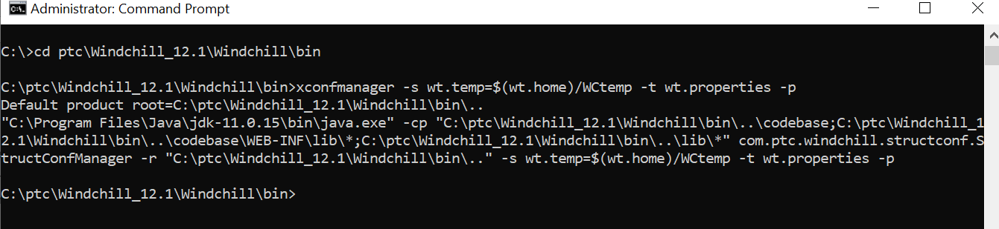

Since property values are cached, the propagated values are not used until you restart Windchill and your servlet engine.

Restoring a Property Value to Its Default Value

Use the --reset parameter on the xconfmanager command to restore one or more properties to their default values. To specify multiple properties in the parameter, separate the properties using a comma.
The following xconfmanager command resets the wt.temp property:
xconfmanager --reset wt.temp -p

Setting a Property Value to the Null Value

Use the following parameter on the xconfmanager command to set one or more properties to null values:
--undefine
To specify multiple properties in the parameter, separate the properties using a comma.
The following xconfmanager command sets the wt.services.service.1160 property to null (which disables the service):
xconfmanager --undefine wt.services.service.1160 -p

Adding and Removing a Property Value to a Multi-valued Property

To add a new classpath entry (d:\MyLibaries\somelibrary.jar) to the Windchill end of the classpath specified in the wt.java.classpath property, execute the following command from the windchill shell:
xconfmanager --add wt.java.classpath=d:\MyLibaries\somelibrary.jar -p
The value d:\MyLibaries\somelibrary.jar is added to the end of the ordered set. You do not have to specify the delimiter $(path.sep) as this will be added to the property value automatically by the xconfmanager.
To remove the classpath entry added in the previous example from the wt.java.classpath property, execute the following command from the windchill shell:
xconfmanager --remove wt.java.classpath=d:\MyLibaries\somelibrary.jar -p
The value d:\MyLibaries\somelibrary.jar is removed

Listing Property Information
Use the -d parameter on the xconfmanager command to list information about one or more properties. To specify multiple properties in the parameter, separate the properties using a comma. The resulting output includes the current value of each property and the location of the files where each property is set.
The following xconfmanager command lists the information for the wt.home property:
xconfmanager -d wt.home
Assuming that the command was executed from the Windows C:\ptc\Windchill\bin directory, then the resulting output is:
Default product root=C:\ptc\Windchill\bin\..
java -jar "C:\ptc\Windchill\bin\..\codebase\WEB-INF\lib\install.jar"
-r "C:\ptc\Windchill\bin\.." -d wt.home
WARNING: Propagation of xconfs to properties was not requested.
To ensure your properties are up to date, re-run with the -p option.
Property information for 'wt.home':
Values:
- C:\Windchill
Locations:
- file:/C:/Windchill/site.xconf, line 9
- file:/C:/Windchill/codebase/wt.properties.xconf, line 17

Validating XCONF Files
You can use the following options to validate XCONF files:
• To validate a site-specific XCONF file, Use:
--validateassite
or to validate a list of site-specific XCONF files, use:
--validatefilesassite
• To validate a declarative XCONF file, use:
--validateasdecl
or to validate a list of declarative XCONF files, use:
--validatefilesasdeclt

Validating XCONF Files Examples

To validate a single file as a site-specific XCONF file, run the command:
xconfmanager --validateassite=<site_xconf>
If the file is valid, then the xconfmanager will issue no output and exit with a return code of zero.
To validate that several files are valid site XCONF files in one invocation, there are two options. You can use the
--validateassite
parameter multiple times. For example:
xconfmanager --validateassite=<site_xconf>
--validateassite=<site_xconf>
The other option is to create a text file, add a line for each path to a file to be validated, then run the command:
xconfmanager --validatefilesassite=<site_list_file>
If all the files are considered valid site XCONF files, xconfmanager issues no output and exits with a return code of zero.
You can validate declarative XCONF files in the same manner using the following parameters:
--validateasdecl
or
--validatefilesasdecl

Other xconfmanager Options
The xconfmanager utility provides additional options that can be useful when setting up a Windchill cluster, performing customizations, or analyzing system problems:
• To specify the root directory that is not the default root directory, use -r. The default root directory is the bin directory under the Windchill installation directory.
The xconfmanager utility uses the root directory when relative paths for XCONF references and target file paths are used.
• To force propagation of all property values listed in the site.xconf, use -F instead of using -p. The -F option forces the propagation regardless of the analysis that is done to determine which files are already up-to-date.
• To generate properties in a format different from the current platform setting, use one of the following:
◦ For the UNIX platform format, use -u.
◦ For the Windows platform format, use -w.
• To turn on additional console output, use either -v (verbose) or -V (debug verbose).

Formatting Property Value Guidelines
The following guidelines will help ensure that you set properties correctly on the command line when using xconfmanager:
• To specify a property whose value contains characters that might be interpreted by your shell (such as spaces and special characters), escape them using the appropriate technique for the shell you are using.
On a Windows system, you can include spaces in a value by enclosing the argument with doubles quotes or you can escape the space character with ^. For example, use either of the following:
-s "wt.inf.container.SiteOrganization.name=ACME Corporation"
-s wt.inf.container.SiteOrganization.name=ACME^ Corporation
On a UNIX system, you can use doubles quotes or you can escape the space character with \. For example, use either of the the following:
-s "wt.inf.container.SiteOrganization.name=ACME Corporation"
-s wt.inf.container.SiteOrganization.name=ACME\ Corporation
• In many UNIX shells, the use of a backward slash (\) escapes the following character as a literal. In most cases, using forward slashes (/) in file paths is a simple way to specify a path without having to know the intricacies of your shell’s command line escaping rules.
• On UNIX, dollar signs are usually interpreted by shells as variable prefixes. To set a property value that has a dollar symbol in it, use single quotes around the argument so that the shell does not interpreted it or use backslash to escape the dollar symbols. For example, use either of the following:
-s 'wt.homepage.jsp=$(wt.server.codebase)/wtcore/jsp/wt/portal/
index.jsp'
or
-s wt.homepage.jsp=
‘\$(wt.server.codebase)/wtcore/jsp/wt/portal/index.jsp

About the windchill Command

The syntax of the windchill command is:
windchill [args] action
You can display the help for the windchill command by executing windchill with the -h argument or with no argument.
The following tables list some of the arguments and actions applicable to the windchill command. To see a complete list of the arguments, use the report generated from the help (argument).

windchill Arguments

Arguments (optional) | Description
-h, --help | Displays help and exits.
-v, --[no]verbose | Explains what is being done when a command is executed. Default is:  -- noverbose
-w, --wthome=DIR | Sets the Windchill home directory. Default is the parent directory containing the windchill script.  On UNIX systems where you have multiple instances of Windchill installed under the same user account, settings made to WT_HOME and SQLPATH environment variables by using this -w option are overridden by any settings to these same variables in the user's .cshrc, .login, and .profile shell initialization files.
--java=JAVA_EXE | The Java executable. Default is the wt.java.cmd variable value specified in the $WT_HOME/codebase/wt.properties file.
-cp,  --classpath=PATH | Java classpath. Default is the wt.java.classpath variable value specified in the $WT_HOME/codebase/wt.properties file.
--javaargs=JAVAARGS | Java command line arguments.

windchill Actions

Action | Description
shell | Sets up a Windchill environment in a new instance of the currently running shell.
start | Starts the Windchill server.
stop | Stops the Windchill server.
status | Retrieves the status of the Windchill server.
version | Displays the Windchill installation version.
properties <resource>  [,...][?key[&key2]...] | Displays the properties as seen by Windchill for the given resource with substitution and other actions executed. It can be limited to a given set of keys.  For example:  windchill properties wt.properties – lists all wt.properties  windchill properties wt.properties?wt.server.codebase – lists server codebase  windchill properties wt.properties?wt.env.* – lists all the environment variables use by windchill shell  windchill properties – generates the help report with no arguments
CLASS [CLASS_ARGS] | Run a Windchill class with optional class arguments. For example:  windchill wt.load.Developer -UAOps

Customization Tutorial

Allocate Database Columns for Local Attributes

To create new local attributes, you first need to allocate space for them in the database. You add columns per database table, per type of attribute for required data type. You can allocate more than you plan to use immediately for future growth.
We will add five number columns to the WTDocument table for use later in the tutorial.
1. From the Windchill shell, run the following command line utility (the expected console output is also shown): AddColumns wt.doc.WTDocument Long=5

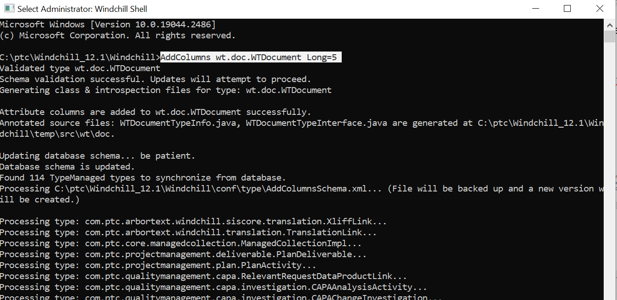
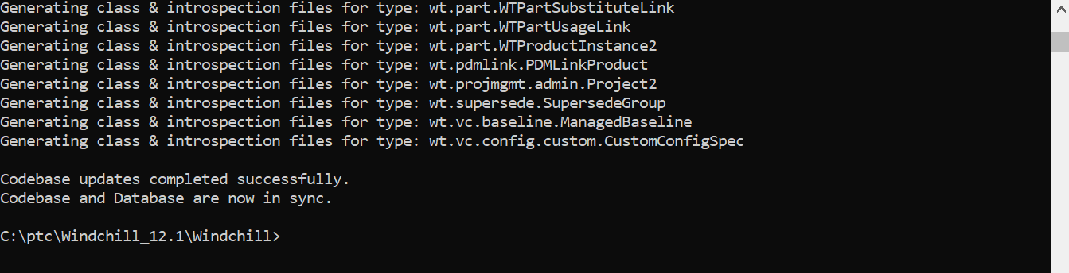

2. The Upgrade Schema window will automatically appear, and disappear, after executing:
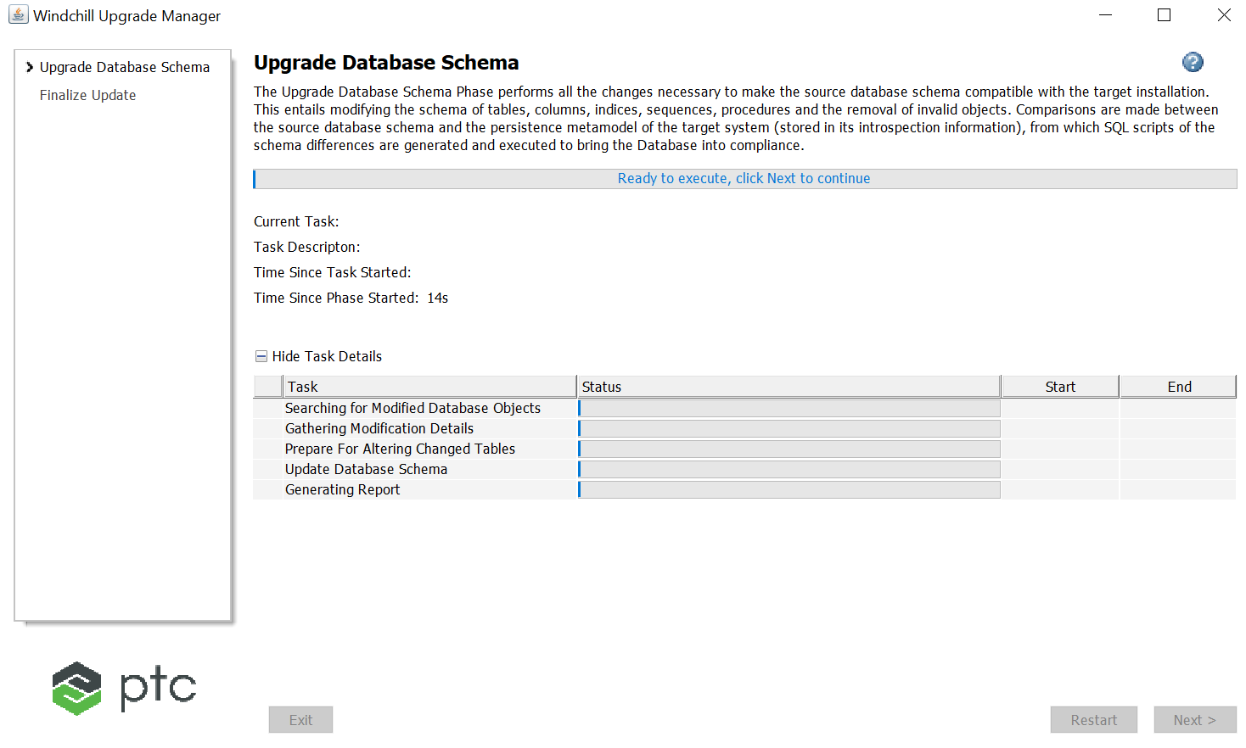

3. The five new columns have been created on the WTDocument table for the respective data type. To make use of them, you must restart the Windchill Method Server. Do that now.

To execute AddColumns utility in cluster environment, perform the following steps on the Windchill Shell:
1. Run AddColumns tool to allocate the standard attribute columns on one of the cluster nodes. For example, AddColumns wt.part.WTPart -f String=2
2. On the other cluster nodes, run the following:
◦ For Windchill Systems prior to 10.2 M030 release, run the following command:
AddColumns -repair wt.part.WTPart String=2
◦ For Windchill Systems after 10.2 M030 release, run the following command:
AddColumns -syncFromDB wt.part.WTPart String=2

Model a New Document Subclass

Create a new source file called AcmeModeledDoc.java in the acme directory. Here are the contents for the source file
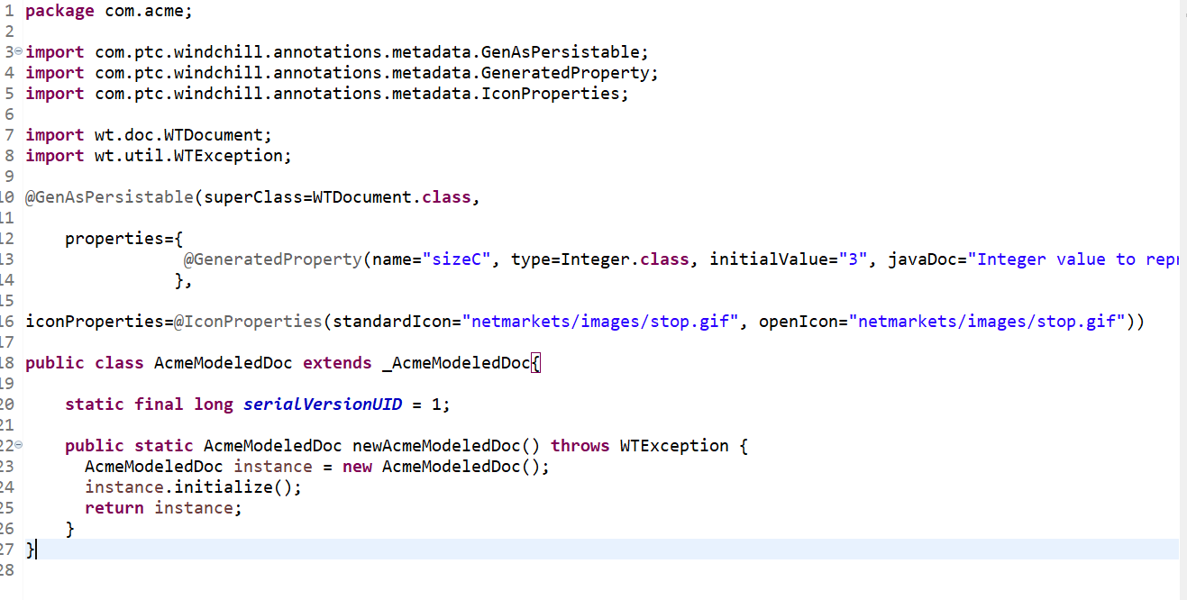
2. Generate the SQL scripts for your new document class. Enter this command in the Windchill Shell:
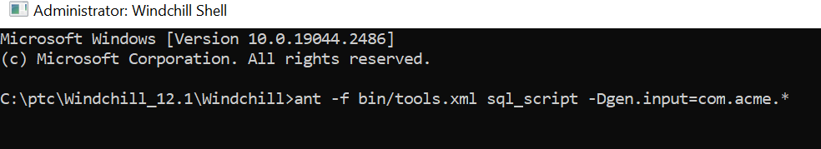

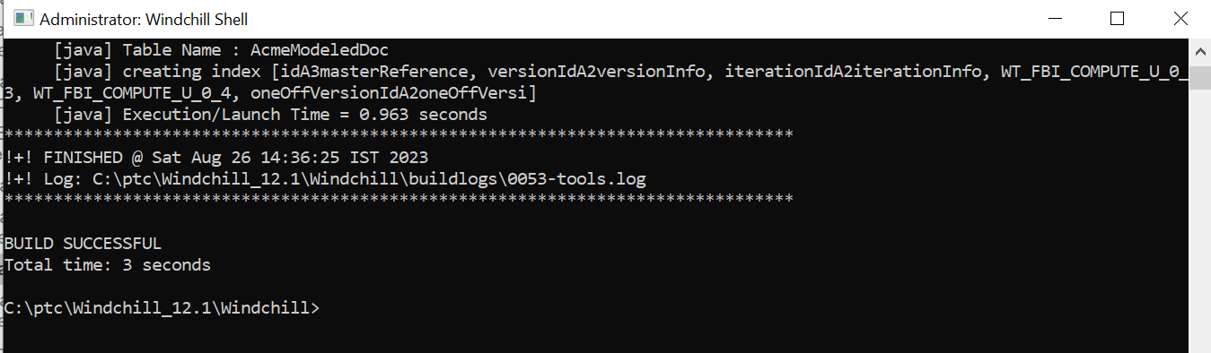

This will generate the SQL commands necessary to create the database schema for your new subclass. You will find the generated schema here: ..Windchill\db\sql\com\acme\create_AcmeModeledDoc_Table.sql
3. Run the below script as shown below.

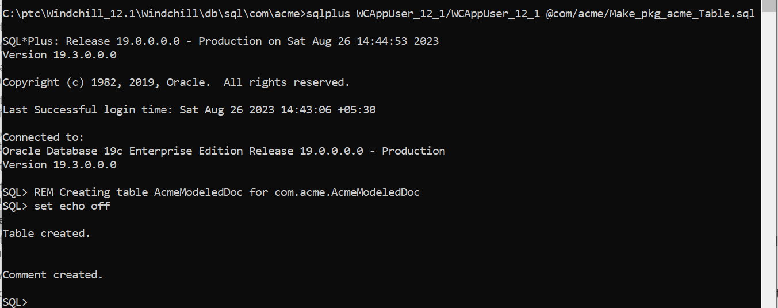

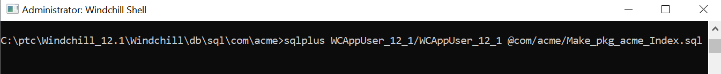

4. Restart the Method Server.
5. As the Organization Administrator, open the Type and Attribute Management. You will now see your modeled document subclass in the type hierarchy. Note the red flag “stop” icon that you specified for your subclass in the model.
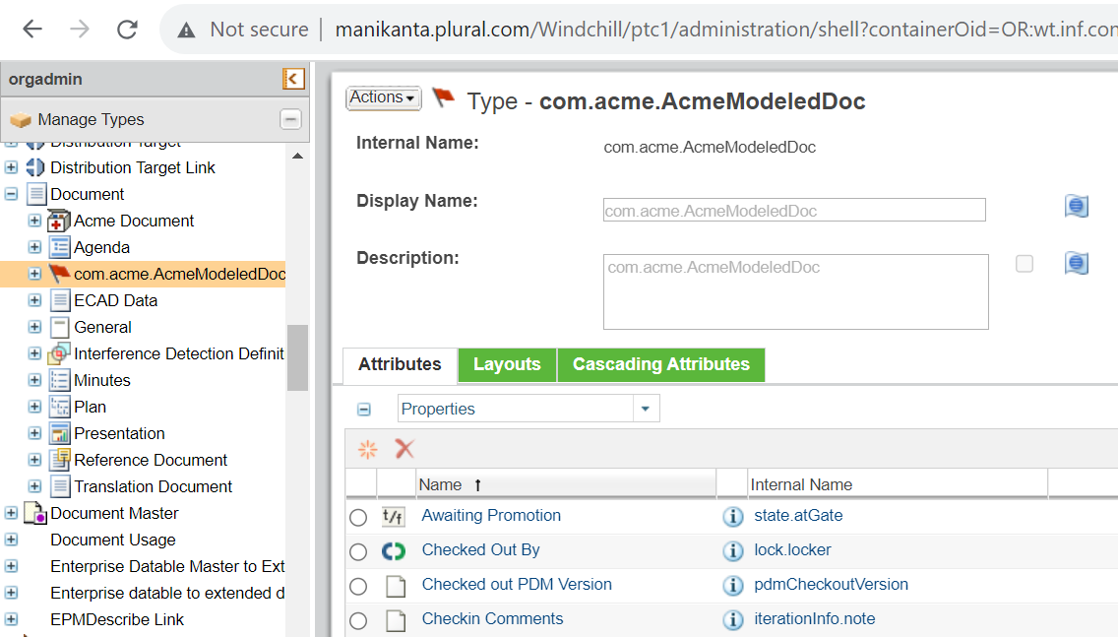
6. We must now change the display name for the sizeC attribute and add it to a group in each layout. Edit your type, and change the default name of the sizeC attribute to “Size C”. Select Save.
7. Select the “Create layout”. Drag the “Size C” attribute to the Attributes column and Save.
8. Select the “More attributes layout”. Drag the “Size C” attribute to the Attributes column and Save and OK.

